Article link-https://edition.cnn.com/2020/11/27/business/china-australia-wine-dumping-intl-hnk/index.html

China slaps tariffs of up to 212% on Australian wine imports
By Michelle Toh, CNN Business
Updated 1621 GMT (0021 HKT) November 27, 2020

Hong Kong (CNN Business)Australian winemakers have been dealt a huge blow from China as tensions continue to spiral between the two countries.
Chinese regulators announced Friday that they would impose heavy tariffs on Australian wines after finding preliminary evidence of dumping. Starting Saturday, China will begin slapping duties of between 107.1% and 212.1% on Australian wine imports, the Ministry of Commerce said in a statement.
The move places yet another hurdle in front of Australian businesses as relations worsen between Canberra and Beijing.
China announced an investigation into some Australian wine imports in August, following a complaint from the China Wine Industry Association. Chinese regulators at the time said that they would investigate 40 allegations of unfair government subsidies in the Australian wine sector.
The Commerce Ministry now says it has confirmed cases of dumping, "causing material damage" to the domestic wine industry in China.
China is by far the biggest importer of Australian wine, according to Wine Australia, a trade organization backed by the country's government. In the most recent financial year, which ended this September, mainland China alone made up 39% of Australia's total wine exports by value, the group said.

This is a devastating blow to those businesses who trade with China in the wine industry," Australian Trade Minister Simon Birmingham said at a press conference on Friday. "We think it's unjustified, and without evidence to back it up."
Australia has upset China this year by calling for an investigation into the origins of the coronavirus pandemic. Beijing later targeted Canberra over trade, namely by suspending some imports of beef and slapping heavy tariffs on barley.
In August, Australia effectively blocked the sale of a dairy business to a Chinese company when an official said the acquisition "would be contrary to the national interest." That business, Lion Dairy, is now being sold to Australian firm Bega Cheese instead, in a deal worth 560 million Australian dollars ($413 million), the companies announced this week.
The wine tariffs come just days after Australia and China both signed onto a major trade deal called the Regional Comprehensive Economic Partnership (RCEP). Some analysts had suggested that the agreement could help the two countries rebuild ties.
Birmingham said that Australia would challenge the tariffs, including by potentially raising the issue with the World Trade Organization.
"The cumulative impact of China's trade sanctions against a number of Australian industries during the course of this year does give rise to the perception these actions are being undertaken as a result or in response to some other factors," he told reporters. The Chinese government has defended its approach. In its statement Friday, the Commerce Ministry emphasized that its investigations were conducted "in strict accordance with relevant Chinese laws and regulations and WTO rules."
China recently acknowledged the frayed relationship — but made clear where it thinks the finger should be pointed. Last week, a Chinese Foreign Ministry spokesperson said that Australia should shoulder the blame for the "sharp downturn" in relations between the two countries.
"The responsibility for causing this situation doesn't lie with China at all," spokesperson Zhao Lijian said at a news briefing.
"[They] have subsequently taken a series of wrong moves related to China, which is at the root cause of China-Australia relations taking a sharp downturn and stuck in the current difficult situation."
— Shanshan Wang contributed to this report.

Commentary

Recently Chinese government has imposed hefty amount of import duties between 107.1% and 212.1% on Australian wine due to complains from China wine industry association of Dumping wines in Chinese market which is harming the domestic wine industry in China. China will impose import tariff on Australia which has many benefits and drawbacks to China and Australia which we will discuss in the essay.

Australia is dumping wines in Chinese market to increase its dominance in china and it will also improve balance of trade of Australia

Dig 1 Impact of dumping in china market

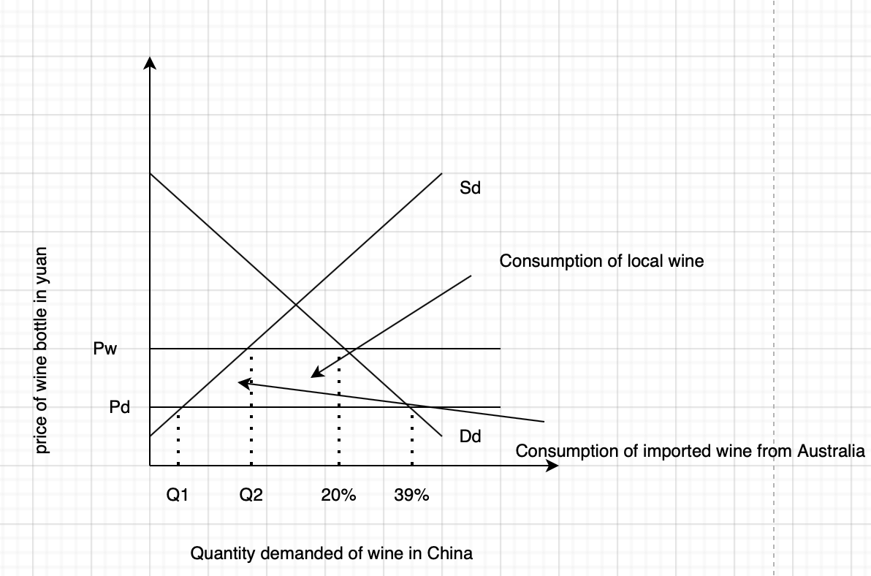

The above diagram explains how dumping has impacted China. As per the diagram consumption of wine has exponentially increased which was 20% at pw but after dumping ,the price has decreased to Pd where consumption of wine has increased to 39%.
Dumping the price below cost of production will impact domestic producer of wine negatively as they won’t be able to sustain in such a low price. Dumping will also impact the GDP of China as consumers will prefer to buy imported wine which is at much lower cost. Lot of import will make balance of trade of china worsen and also decrease the government revenue.

However, dumping will improve Australia’s balance of trade as more wines will import to china than before. It will also appreciate Australian dollar as the demand for the currency increase and also improve GDP of Australia as more winery will set up in the country.

The Chinese government will impose protectionist policies to protect domestic industry

The imposition of import tariff in Australia will cause lot of drawbacks because it will affect Australian’s currency negatively as it will decrease the export of wines to china which will decrease the demand of Australian dollar which will depreciates its value in comparison of yuan and it will also affect the relationship of china and Australia. The tariff will also affect China in both ways negatively and positively, as the tariff will help many infant wine companies of china to increase their revenue but it will also harm many companies who are rely upon Australian wine for cheaper cost.

Dig 2 Import Tariff on Australian wine

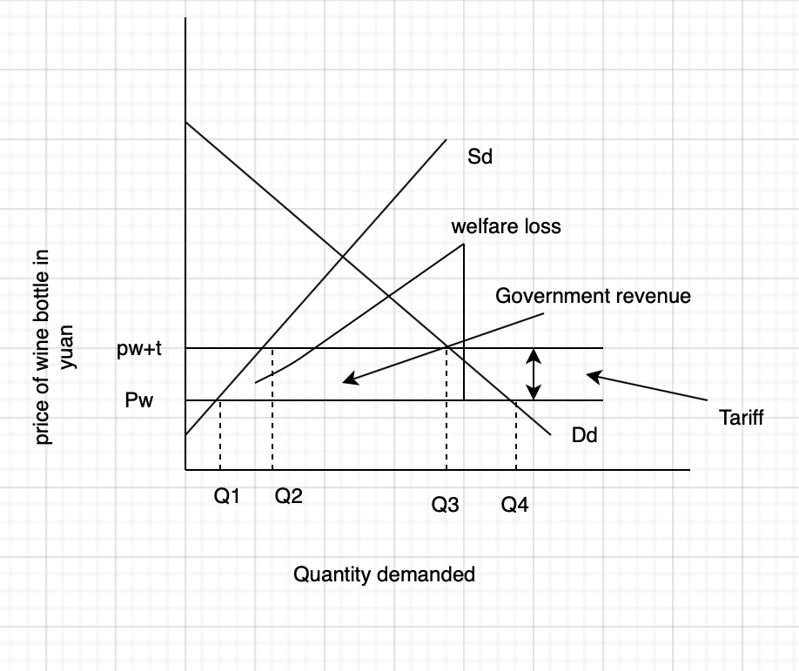
Of 212 %
of wine

The diagram shoes the consequences of tariff in china and Australia. In the diagram above Pw represents world price=world supply and Pw+t represents world price after tariff, both world supply curve is perfect perfectly elastic which means china can buy and sell any quantity of bottle at world price. Sd represents domestic supply of wine and Dd represents domestic demand of price.

According to the above diagram Quantity supply of wine at Pw+t has increased to Q2 from Q1 whereas the demand for wine in china has fall due to increase in the world price from Pw to Pw+t which clearly shows that domestic consumers are worse of due to increase in the price level of wine and producers in china are better off due to increase in the world price. Import of Australian wine has decreased from Q3 to Q2 due imposition of tariff which is upto 212%. Although Chinese government are better off as they will earn revenue of whatever quantity of wines are importing at the new world price which is Pw+t. In above diagram there is a welfare loss shown because of imposition tariff which has caused misallocation resources due to inefficient producers of wine in the Chinese market.

The tariff will benefit china’s market as it will help many infant wineries company beacuse they will get opportunity to target the customers of Australian wines which will increase the employment and GDP of china. Before tariff china Imports 39% of total wine from Australia so now tariff will help them reduce the balance of deficit because now there will be lesser imports from Australia.

Although, the tariff will also affect china’s market with Australia. the tariff will make some of the goods expensive which are dependent upon wine which might cause cost push inflation in China which might affect the GDP of the country. Domestic producers will be better off as they can sale their wine at world price which is higher than before and it might

misallocation of resources as it will increase the inefficiency in wine production. The tariff will worsen the relationship between China and Australia which also affect their recent trade agreements.

Although tariff will affect Australia negatively. It will affect their trade relationship which will impact RCEP agreement. Due to less import, there will be less production of wine which will cause cyclical unemployment in Australia.

In conclusion China government should Impose quota on wine to minimise dumping as it will not affect the relationship between both countries.

