Read more at:
https://www.thehindu.com/business/Economy/covid-19-federal-reserve-cuts-key-interest-rate-due-to-coronavirus-risk/article30974486.ece

COVID-19 | Federal Reserve cuts key interest rate due to virus risk
WASHINGTON, MARCH 03, 2020 20:56 IST

The U.S Federal Reserve implemented on March 3 an emergency rate cut, responding to the growing economic risk caused by the coronavirus epidemic and giving President Donald Trump the stimulus he has called for.
Also read | Coronavirus infects global markets, investors exit equities | Coronavirus: Full coverage
In a unanimous decision, the Fed’s policy-setting committee cut its key interest rate by a half point to a range of 1.0-1.25.
The large, highly unusual cut, taken just 15 days before the next scheduled policy meeting, reflected growing concerns that the spreading virus will take a bite out of the U.S. and global economies, as supply chains linked to China, the epicentre of the outbreak, are shut down.
While U.S. economic fundamentals “remain strong”, the “coronavirus poses evolving risks to economic activity”, the Federal Open Market Committee said in a statement.
The central bank “is closely monitoring developments and their implications for the economic outlook and will use its tools and act as appropriate to support the economy”.
The Fed has not made an inter-meeting rate cut since late 2008, during the global financial crisis.
After the announcement, Federal Reserve chairman Jerome Powell said the emergency interest rate cut will provide a “meaningful boost to the economy” in the face of the coronavirus epidemic.
But Mr. Powell said it is unclear how long the outbreak will last, acknowledging “a rate cut will not reduce the rate of infection, it won't fix a broken supply chain”.
“We get that. We don't think we have all the answers. But we do believe that our action will provide a meaningful boost to the economy,” Mr. Powell told a press conference.

Stocks sell-off
Wall Street stocks tumbled in late-morning trading on March 3 after the Fed announcement.
Near 4.30 p.m. GMT (10 p.m. IST), the Dow Jones Industrial Average stood at 26,159.67, down nearly 550 points or 2%.
The broad-based S&P 500 slid 1.8% to 3,034.00, while the tech-rich Nasdaq Composite Index shed 1.6% to 8,805.92.
Stocks initially rallied after the Fed's surprise rate cut announcement, but equities later gyrated as investors questioned whether the move suggested the U.S. economy was on shakier ground than previously thought.

Commentary
The above article explains about economic stimulus package introduced by government of USA in order to get rid of economic crisis going on due to ongoing pandemic.

The nations lockdown has caused massive cyclical unemployment in the country as The economy has gone to recessionary gap where there is mass unemployment is greater than naturel rate of employment due to ongoing economic crisis
Figure 1: - ]Recessionary gap in Keynesian section
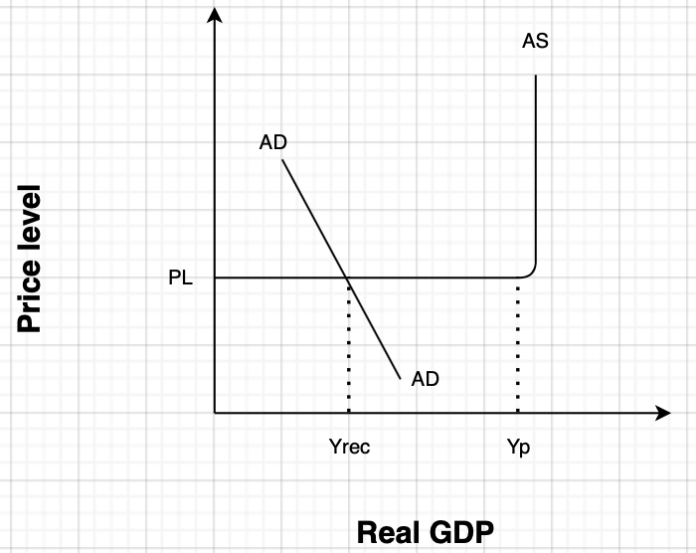

The above Keynesian diagram shows how the USA economy is suffering recessionary gap due to current outbreak. USA economy is currently in the recessionary gap as we can see AD curve intersects AS curve in Keynesian zone at Yrec whereas potential capacity of the economy is at Yp where unemployment is equal to natural rate of unemployment, although price level remain constant in Keynesian zone due to labour market rigidity. The recessionary gap has happened because of low consumption in the economy which is the part of 4 components of economic activity (measures of economic activity that have eliminated the influence of changes in prices.) C + I + G + (X − M) so consumer spending has decreased in the economy due to restriction of movement because of nations lockdown which shifted economy to Ye and has caused massive unemployment in the country. Higher unemployment has decreased the spending power of consumer due to low disposable income less so it has also left impact on “I” (investment) because of low demand in the country new firms will not willing to invest any capital to start a new venture in the country so the real GDP of the country might get worse if any intervention of government won’t happen.

To minimize the recessionary gap in the economy the Federal bank has intervened by imposing expansionary monetary policy by the help of which the economy may come on the track which has got disrupt due to the Outbreak.

Recently Federal bank has lowered down the interest rate by a half point to a range of 1.0-1.25 which has given some hope to sunset businesses for being functional and it also encourages employment in USA economy which will influence aggregate demand.

Figure 2:- Keynesian model after intervention of government
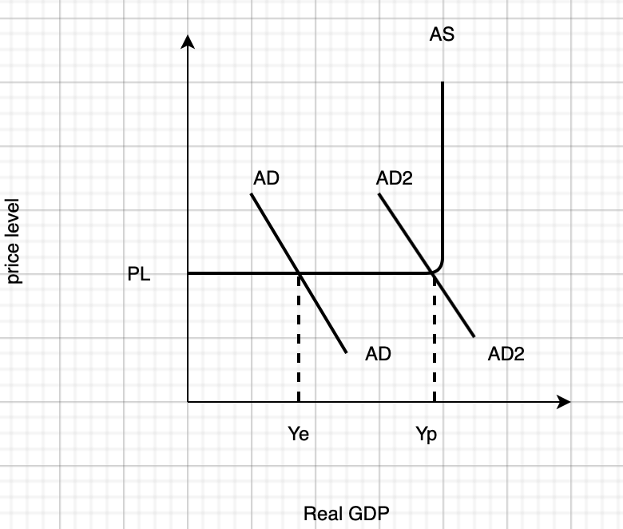

The above diagram is called Keynesian model which shows the consequences of fiscal policy implement by the government initially Real GDP of the economy is at Ye which is equivalent to recessionary gap of Figure 1 above after implementation of expansionary monetary policy in which government has reduced interest rate half point to a range of 1.0-1.25 for companies in order to support them in this crucial times. The expansionary monetary policy has shifted AD(aggregate demand) to AD2 because lower interest rate will attract more companies to USA economy which will bring employment equal to natural rate of unemployment which means higher unemployment, higher income which will impact consumer spending in the economy and government will able to minimize the mass employment happening in the society . Consumers will not willing to save money in the bank as the interest rate has been reduced and due to higher aggregate demand in the society more MSMe companies are willing to invest their capital in USA economy for the bebefit given by the government. So now the economy will function at point Yp where natural rate of unemployment is equal to employment.

However, expansionary monetary policy can be implemented instantly by Federal bank which will help to recover USA economy to go into recession, due to central bank independence there is no political constrain to implement the policy which will help Federal bank to implement fast. Although there might be time lag in implementing this policy as the central bank needs time to figure out the problem and decide the new rate interest accordingly and by then economic crisis can get more severe. According to the Mr. Powell the economy needs supply side policies to overcome with economic crisis and it will not make supply constraint in the economy so US government has to intervene and should implement market-based policy such labour market reform by weakening the power of labour union which we give benefit firms to hire labour at much lower wage which will increase the supply and so the firm able to meet increase demand in the economy. Although government should reduce taxes which will give incentive to firm to supply more goods in the economy in order to minimize supply constraint.

In conclusion US government should implement supply side policy with demand side policy to run us economy smoothly in the outgoing pandemic.

