International Baccalaureate Business Management HL Extended Essay

Research Question -
To what extent has Kering been able to ameliorate its market positioning in European fashion industry with its premium brands?

Title : Market positioning of a luxury-fashion-group

Session: May 2021
Word Count: 3997

Table of Contents

Introduction 4
Background of Kering 4
Introduction to the essay 4
Methodology 6
Results and Findings 8
Intangible-assets Valuation 8
Non-Financial aspects 8
Differentiation and Salience (Unique Identity) 8
Relevance and Esteem 10
Awareness and Loyalty 10
Financial Aspects 13
Brand Association 13
Other Proprietary Responsibilities 13
Marketing Mix (4P’s) 16
Brand 16
Brand’s Product Portfolio Analysis 17
Perception mapping 18
Brand’s Product wise Revenue 20
Packaging 22
Price 24
Place 24
Promotion 26
STP (Segmenting-Targeting-Positioning) Framework Practice 27
Market-positioning method 28
International-promotion (across Europe) 29
E-Platform 29
CSR & Ethical-Objectives 30
Industry Analysis 31
Impact of pandemic and measures taken 31
Financial View 34
Market-Share Analysis 34
Revenue Analysis 35
Conclusion 36
Works Cited 38
Appendices 41
Appendix 1 – Celebrities Endorsements of Kering’s Brands 41
Appendix 2 – Some seasonal collections of Gucci (a Kering brand) 43
Appendix 3 – Factual Figures 45
Appendix 3.1 – Consolidated income statement (year ending Dec, 2019 & 2018) 45
Appendix 3.2 – Social Media presence 45
Increasing value of online luxury-goods market worldwide (as of 2020) 45
Most popular Twitter pages 46
Appendix 3.3 – Year-wise revenue of Kering 46
Appendix 4 – Kering’s brands basic background 47
Appendix 5 – Publicity 48
Appendix 5.1 – Renowned Celebrities who buys Kering’s Brands 48
Appendix 5.2 – Popular Songs on Kering’s Brands 49

Table of Figures

Figure 1 - Kering and its Brand's Logos 9
Figure 2 - The top 15 most popular luxury brands online in 2020 12
Figure 3 - Gucci's beloved 'The Jackie 1961' handbags 14
Figure 4 - Consolidated Non-current assets of Kering (December 31, 2019 & 2018) 15
Figure 5 - Perceptual Map of major Luxury Houses 19
Figure 6 - Kering's product wise revenue distribution (2019) 20
Figure 7 - LVMH's product wise distribution (2019) 21
Figure 8 - Gucci's new 'Green' coloured, sustainable packaging 22
Figure 9 - Yves Saint Laurent's biodegradable packaging 23
Figure 10 - YSL's refillable and eco-designed packaging 23
Figure 11 - Girard Perregaux's lavish packaging 23
Figure 12 - Interior of Gucci Milan, Italy. 25
Figure 13 - Directly operated Kering stores region-wise 26
Figure 14 - Year-wise value of personal luxury-goods market (in billion euros). 33
Figure 15 - Year-wise market share of Kering 34
Figure 16 - Brand wise Revenue of Kering's brands 35

Introduction

Background of Kering

Kering is a an French-based multinational luxury group, headquartered in Paris, France, promoting modern and sustainable luxury-goods providing an unique and authentic-experience to its customers. It was founded as a timber-trading company, known as Pinault S.A., by Francois Pinault in 1963. However, since 1999, it is a group building portfolio of luxurious-brands across the world, especially in European-countries. It owns and manages the development of a series of renowned fashion-houses, jewellery, leather-goods, and watches and is working sustainably where possible to enhance its market-positioning.
Kering sounds similar to ‘caring’ and ‘ker’ means ‘home’ in France’s western cultural-region, which helps in promoting its brand as a necessity for cultural-identity giving home-like care. It’s also the main owner of premium-brands like Gucci, Balenciaga, Boucheron etc.

Introduction to the essay

This essay mainly focuses on the marketing-section of IB business management course. And I’ll be exploring this by analysing marketing-mix of a French-conglomerate, with a portfolio of luxury- brands, highlighting its various strategies which is helping the company to ameliorate its marketing position across European fashion-industry by affecting perception of its stakeholders.
And since my ambition is to reform my family business as a premium-brand in my country, it is immensely essential for me to become cognizant with the framework of premium companies who are among pinnacle of their industry. Thus, evoking the research question - “To what extent has Kering been able to ameliorate its market positioning in European fashion industry with its premium brands?”.
This research is extremely enthralling since analysis is completed with varied antithetical-aspects which together establishes a luxurious-positioning of affluent-brands at the continental-level providing insightful-knowledge to readers, keeping them interested in reading this essay.

Methodology

In order to answer the research-question, varied primary and secondary-resources were incorporated from authentic and reliable-sources in order to analyse European-market, Kering’s strategies, various-trends etc.
Secondary-research was carried out by using financial-data and news-articles of Kering and its competitors from world-wide acknowledged sources. Along these, some business journals and textbooks were also used which helped in analysing the extent of Kering’s market-position as compared with its competitors. However, some information pooled from these might be irrelevant to the research since some data might be outdated and trends changes rapidly in dynamic business-world (especially in fashion-industry).
Because of this, I decided to conduct an ambience-observation (primary-research) later, by visiting few premium fashion-stores like Gucci (a Kering-brand) and its competitor Prada in India. This gave me a better insight onto current-trends, employee-customer relationship and few other techniques marketers use in this industry in order to appeal to their target-customers. However, the findings might be unreliable with limited application since the ambience at an Indian-store is certainly different from European-stores with different customer’s taste, preferences and spending-capacity.
Along these, various financial and non-financial tools were used to analyse qualitative and quantitative aspects of this research in order to make this research more balanced and meaningful that helped in framing more authentic and reliable conclusions giving a pellucid-answer to my research-question.
A marketing mix of 4-Ps was used to analyse market-positioning of Kering which was complemented further with non-financial strategic-analysis tools like brand position-perception-mapping, brand-portfolio-analysis, STP-framework-analysisetc. Later on, financial aspects of Kering and luxury-industry were also analysed for a balanced-research by measuring current and expected-growth of Kering and the industry which gave a rough-estimate about Kering’s financial-position as the financial-figures used in the essay may not be accurate and include decorated-figures. Later on, after realising that these tools didn’t provided sufficient analysis of intangible-assets of Kering, therefore, I did an Intangible-assets-valuation with its financial and non-financial aspects. I also added another aspect of study later for better-insights into current-situation of Kering in this dynamic-business-world where I analysed impact of pandemic and lockdown across the world and recent changes in premium fashion-industry in order to enhance my research’s quality.

Results and Findings

To begin with the essay, an intangible-assets valuation of Kering was done which is further complemented by 4Ps of the marketing-mix among others in order to gain a pellucid insight on Kering’s premium-brand’s market-positioning.

Intangible-assets Valuation

In order to explore how a luxury-group as Kering, maintains and enhances its market-positioning, one must analyse and discuss the role of various intangible-aspects consistently acting-upon and affecting brands-value of a luxury-group to understand the value of intangible-components of Kering’s brands that has helped and are helping Kering to improve its market-positioning across Europe. Therefore, an intangible-assets-valuation was done by examining major financial & non-financial aspects of intangible-assets.

Non-Financial aspects

The major non-financial aspects are as follows:

Differentiation and Salience (Unique Identity)

Differentiation is an act of distinguishing a brand and its product from rivals in the industry. The process makes the product/brand unique and special which adds up to the brand’s value, giving the brand/product a competitive-advantage against rival’s product. This helps in building unique-identity of brand.
Kering’s brands like Gucci, Balenciaga etc. have established their brand-identity by differentiating themselves from its competitors like LVMH, Hermes, Burberry, Richemont, Prada etc. It did so by designing unique up-to-date products as per the latest trends (releasing a collection every season) . Along this, their simple, elegant and distinctive-logos, attention-capturing slogans and extremely palatial and lavish store-outlook has created a luxurious-image and higher perceived-quality of Kering and its brands in its stakeholder’s mind, evoking a sense of desire for Kering’s products. All this has helped Kering over decades in establishing a strong identity in the luxury-fashion-industry and enhanced its brand-loyalty which as a result, benefitted it by attracting more potential-customers & retaining existing ones, reducing marketing-costs and in prolonging its brand’s life-cycle.
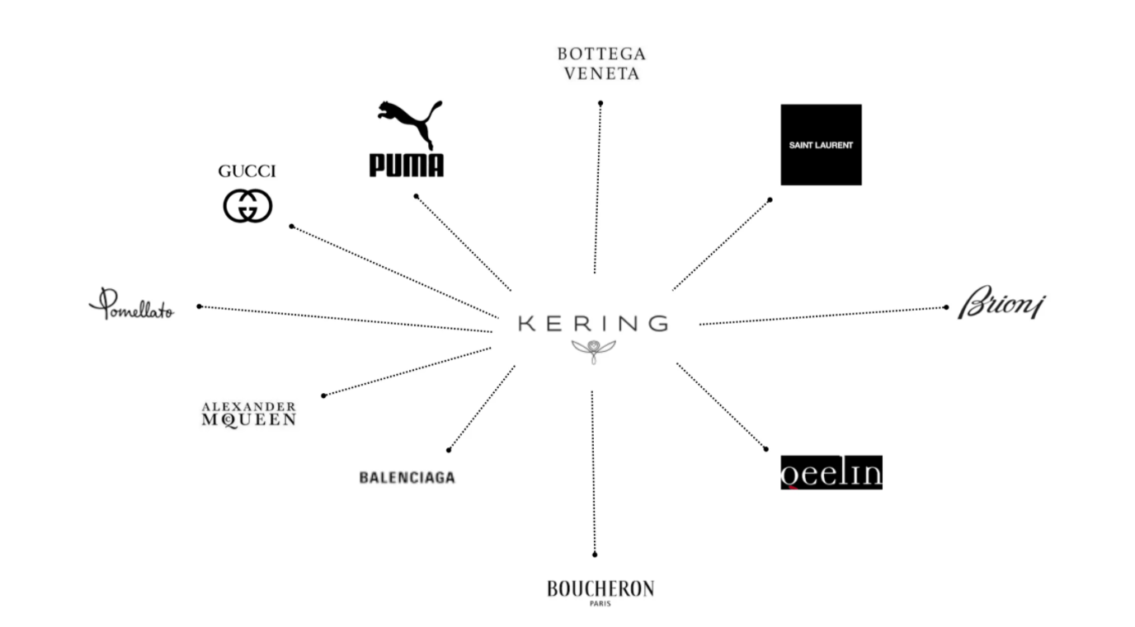
Figure 1 - Kering and its Brand's Logos

Relevance and Esteem

Being the owner of luxurious-brand, Kering uses varied techniques like social-media, customer feedback-form, external market-research etc. in order to gain a better insight into current-trends across the world and then its brands releases a new collection every-season. It also uses celebrity-endorsements in order to impact the current-trend, in per favour. These helps in making the costly, high quality-products relevant to customer making them appreciate the distinctive physical-attributes giving the end-user a sense of improved personality and a certain attitude with poise. It also complements the shopping-experience of buyers by providing a sense of higher social-status and affluent-feeling, making the clothing-accessories speak for the person’s status. As a result, helping Kering penetrate the industry effectively and efficiently.

Awareness and Loyalty

Brand-awareness refers to the degree that stakeholders are familiar with distinctive-qualities of a particular-brand and measures the degree of brand-recognition. Brand-loyalty occurs when customers buy from the same brand repeatedly from time to time instead of its competitors. Instead of targeting the mass-market, Kering has been improving its branding-aspects in a selective-class of consumers who are from the richer-segment of the society and desire high-quality personalised-goods. Thus Kering uses various tactics in order to establish a higher brand-awareness and loyalty by targeting these niche-groups than mass-marketing. They do so by cultivating customers-relations by organising various fashion-shows, providing personalised-services etc. enhancing communication of preferences between Kering and its buyer.

However, differentiating these techniques from competitors is extremely-difficult and lots of brands fails to execute their strategies effectively. But, Kering has been able to succeed in it by being equitable with its employees (and other stakeholders) and heavily investing in its CSR which has now became the major defining element of Kering. One such evidence for this can be further seen in Fig.-2 where 3 of Kering’s brand (Gucci-1, Balenciaga-6, Yves Saint Laurent-8) are ranked at the top of list leaving its competitors (Burberry-10, Hermes-11 etc.) behind. The new-entry into Kering Eyewear (diversifying portfolio), has also helped in spreading more awareness to some extent. Thus, helping Kering enhance its market positioning across the continent.
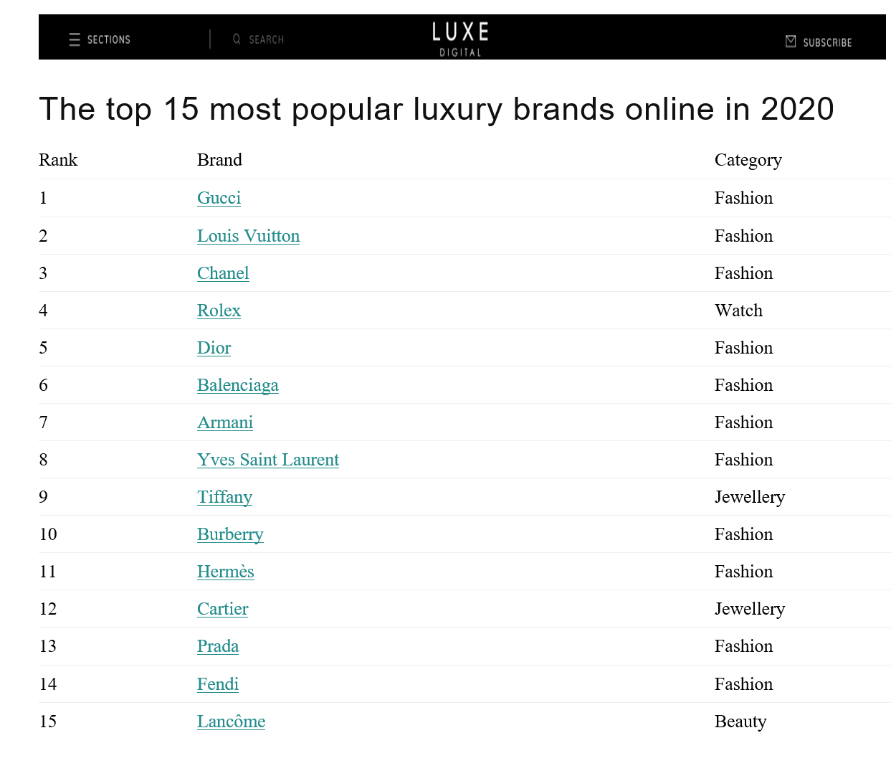
Figure 2 - The top 15 most popular luxury brands online in 2020

Financial Aspects

The major financial aspects are as follows:

Brand Association

Brand associations are those images that the customer or general public relates with a brand. Kering’s brands are associated with celebrity’s fashion which enhances its brand-value to some extent, making its premium-price justifiable. This also gives a sense of exclusivity to buyers making them value the purchased-item.
Kering’s name is homophone to ‘caring’ portraying Kering’s aspiration to look after its stakeholders in every possible-way. The image of Kering being a French brand since 1963, integrated with ‘owl’ in its logo are deeply ingrained into the brand’s perception which acts as a synecdoche to Kering’s visionary-foresight, personality and ability to anticipate trends and potential in people and brands. ‘Owl’ is also viewed as an intelligent-bird filled with wisdom and is connected with Hindus and Greece goddesses ‘Laxmi’ and ‘Athena’ symbolising “main source of income”. And these associations helps in increasing market-share and establishing higher barriers to entry.

Other Proprietary Responsibilities

Other Proprietary Assets includes patents, copyrights, intellectual-property, relationship with trade-partners etc. Kering’s intellectual-property includes its logos, designs, photographs, written texts etc. The most valuable IP tool that an organisation in the fashion-industry has is protection on new-designs. Products with iconic names like Gucci’s contemporary ‘The Jackie 1961’ handbags, Balenciaga’s perfume named ‘Flora botanica’ etc. are also trademarked besides brand’s name, logos, mission statements etc. This is crucial because a product’s name defines its physique, style and enhances its market-positioning in buyers’ mind by giving them a sense of buying something exclusive. In addition, reliability of Kering with its trading partners is extremely vital. Thus, payments are done via secured online-gateways and credential-documents exchanges are always encrypted making B2B data exchange safe, reliable and efficient which has enhanced Kering’s relationship and perception with its trading-partners.
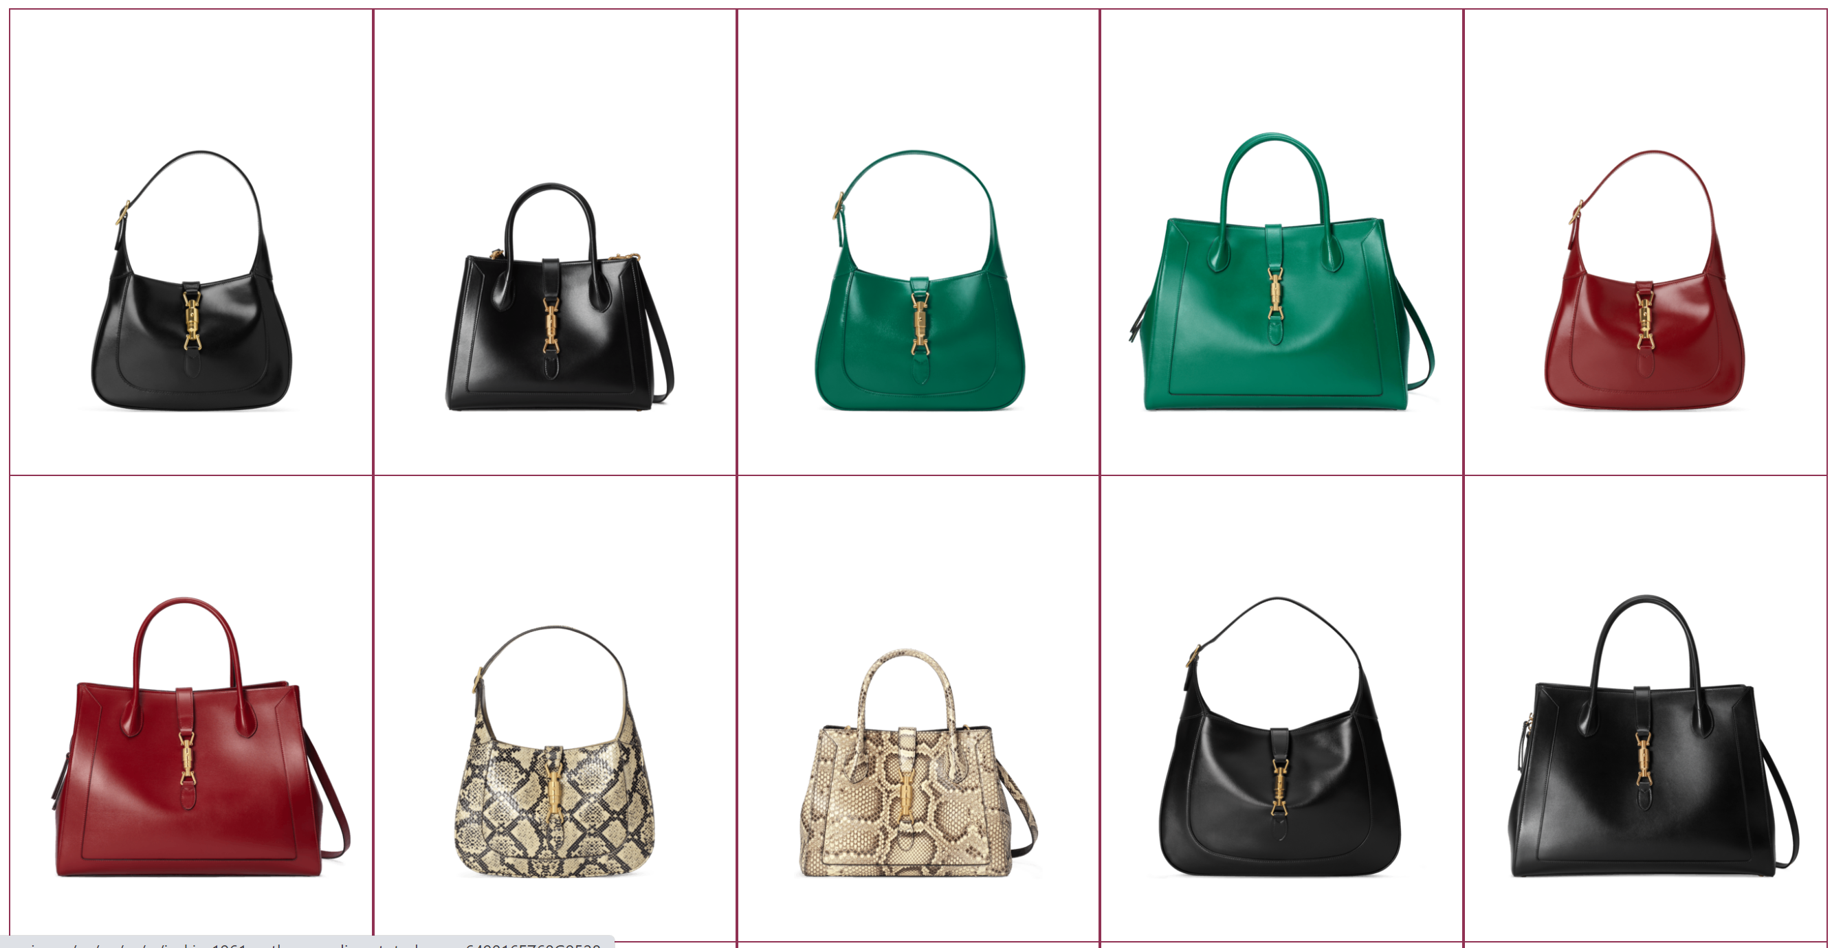
Figure 3 - Gucci's beloved 'The Jackie 1961' handbags
All these intangible-elements have a monetary value which is increasing with time and helps in building a stronger brand-perception in the industry thus, enhancing market-positioning. And Kering is heavily investing its resources and time to enhance these elements more and more using varied tactics as discussed above.
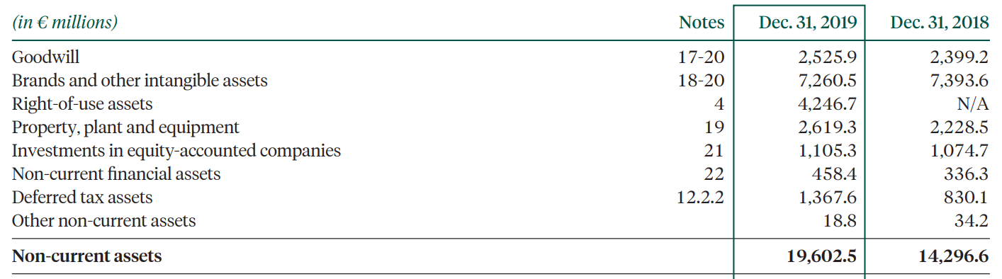
Figure 4 - Consolidated Non-current assets of Kering (December 31, 2019 & 2018)

A major drawbacks of doing Intangible-assets valuation is that measuring intangible-assets into a monetary value is difficult. And it is also unable to evaluate and analyse the effectiveness of the strategies in question. Here, limited factors and perspective constraints the broad scope of research, making the analyses very general with negligible domain left for evaluation. Because of these limitations, Kering’s marketing-mix is also analysed, discussed and evaluated for further research, making it more substantial.

Marketing Mix (4P’s)

A marketing-mix is used to review and develop marketing-strategies which incorporates varied interdependent-elements that are needed to successfully market a product. Since, the research-question is based on marketing, analysing marketing mix of Kering is important as its insights will help in getting a much more detailed and coherent-picture of the situation and will make the research’s findings and conclusions more authentic and reliable.

Brand

Since Kering is a holding company of luxurious-brands, instead of using ‘Product’ element of marketing-mix, ‘Brand’ element is used. However, a product-portfolio analysis to segregate the product type in the portfolio was conducted to aid research.
Luxury-goods produced by Kering’s brands are produced with detailed and unique customized-designing, exclusive-production and have a higher worth. Kering’s brand Gucci’s craftsmanship is among the top of its line with its elite equestrian-style and that too with Florentine leather finishing which complements the organisation with a competitive-advantage. Unlike its competitors, Kering doesn’t use animal products due to its high sustainable goals and its environmental-friendly image. That’s why most of products uses specialised cotton-canvas as its raw materials instead of leather. The same designs are used worldwide, thus, reducing R&D costs. This strategy also makes it easier to manufacture products as they can be manufactured in their respective origin-countries.

Brand’s Product Portfolio Analysis

A BCG-matrix of Kering’s luxury-goods is created in order to assess individual product type based in term of its market-potential. This helps in reviewing and implementing strategies to make a balanced-portfolio. Since, Kering’s brands have wider range of luxury-goods, it would’ve been difficult to present all of them in BCG matrix. Therefore, all luxury-goods have been segregated by grouping into several categories aiding reader’s readability and understanding as well.

 |  | Market-Share
 |  | High | Low
Market-Growth | High (Growing) | Stars  - Ready-to-wear fashion accessories  - Couture and Leather goods | Question Mark  - Watches and Jewellery
Market-Growth | Low (Mature) | Cash Cows  - Perfumes  - Silk and textiles | Dogs  - Other-goods (textile-printing etc.)

As per the matrix above, the products with higher market-share and growth are ready-to-wear fashion accessories and couture & leather goods, hence Gucci, Saint Laurent, Balenciaga, Bottega Veneta, Brioni and Alexander Mc Queen are ‘stars’ while Boucheron, Qeelin, Dodo are ‘Question Marks’ as these brands produce watches and jewellery amidst other luxury-goods.
BCG-matrix certainly provides insightful information about a brand/product’s market’s potential. However, it doesn’t measure how big the market is. This implies that even after a higher market-share in a niche-market, the business might be earning small revenue than ‘Dogs’ with a smaller market-share of a comparatively bigger-market. In overall, assumption that higher market-share results into more profits can’t be made. Therefore, the research is further complemented with a positioning-map of Kering (where Kering’s brands are compared with its major competitor’s brands) and by examining brand-wise-revenue of Kering with its top-competitor, LVMH.

Perception mapping

Fig.- 5 is a perceptual map prepared by Céline, a brand of LVMH group (i.e. the major competitor of Kering group holding luxury-houses like Céline, Louis Vuitton, Fendi, Christian Dior, Bulgari, Tiffany and Co. etc.). Implying that this map is authentic and reliable making its findings trustable since, the major competitor of Kering prepared this map for its personal-use.
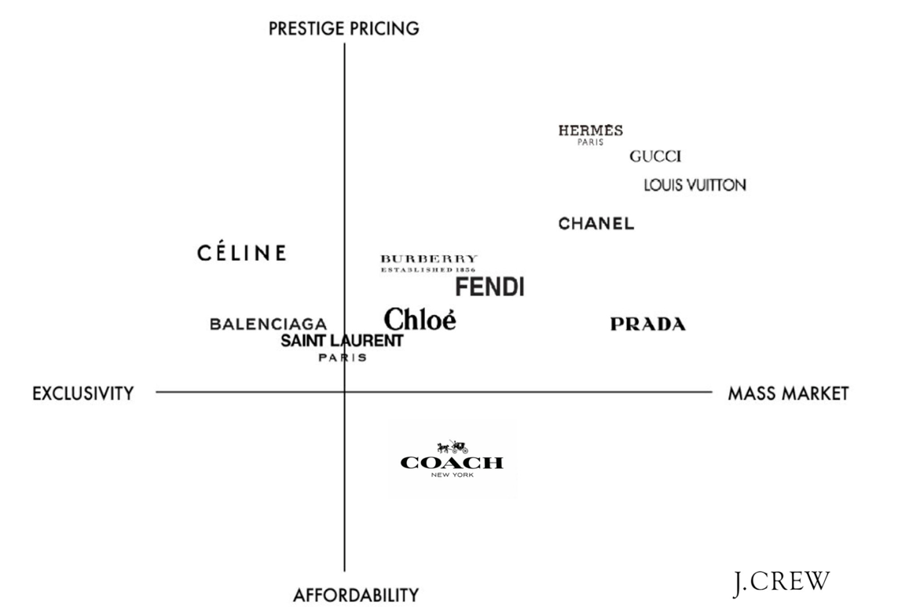
Figure 5 - Perceptual Map of major Luxury Houses

It is evident from the map that Gucci is a premium brand, among its top-competitors, followed by Hermes. While Balenciaga and Saint Laurent are comparatively exclusive and cheaper. This justifies the claim of ‘selective-grouping’ in a niche market of affluent buyers, as stated in non-financial aspects of intangible-assets valuation. The only limitation here is that this map is taken from internet where multiple conflicting maps of luxury-brands were already available. Thus there is scope of bias to some extent, however, it was reduced by verifying information in the chosen map with numerous other trusted-sources.

Brand’s Product wise Revenue

As mentioned above, Kering’s chief rival across Europe is LVMH, a French MNC and conglomerate specialised in luxury-goods owning premium-brands like Louis Vuitton, Bulgari, Sephora, Fendi etc. In this part of analysis, product wise revenue of Kering and LVMH have been analysed using pie charts in order to find major revenue generating goods of both organisations. This is necessary to know as this plays an important role while making marketing-strategies. Thus, helping us to understand various strategies of Kering in a better way.
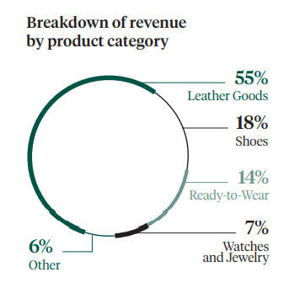
Figure 6 - Kering's product wise revenue distribution (2019)

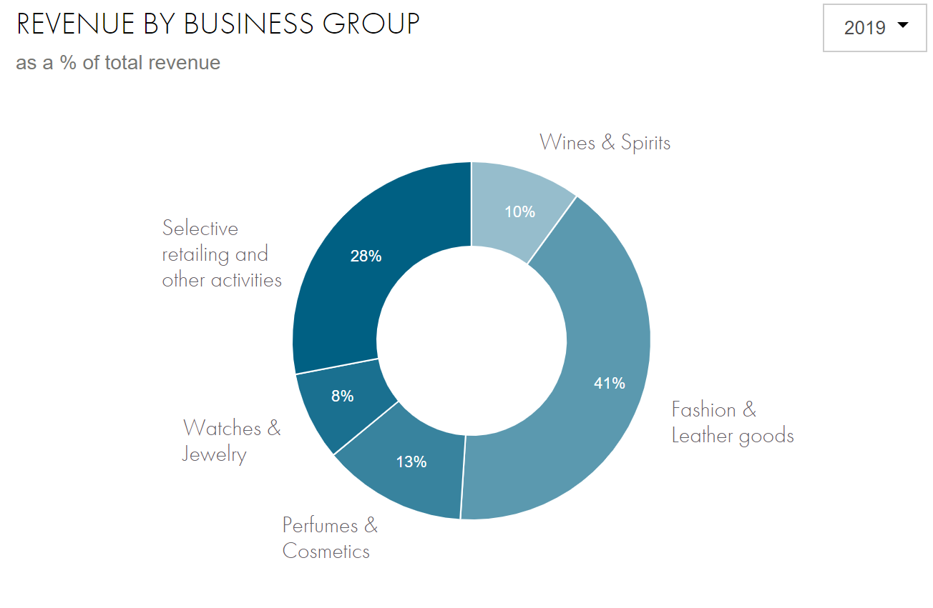
Figure 7 - LVMH's product wise distribution (2019)

From fig.-6 & 7, it is evident that fashion and leather goods (combined) of LVMH, doesn’t even come close to the revenue percentage of Kering for the same. However, LVMH is leading in certain fields like watches and jewellery, other activities etc.
The position perception mapping and product-wise revenue breakup provides information about the leading brands and products in the organisation and the industry, which constitutes some elements of Kering’s competitive analysis thus, giving a pellucid picture of the luxury-industry. But, it doesn’t provide much information from customer’s preferences between Kering and its competitors.

Packaging

Packaging has a profound-effect on customers and acts as a form of differentiation, thus promoting the brand. It not only protects the product against damage but also encourage impulse-buying. Kering achieved carbon-neutrality in 2018 and is extremely environmental-friendly which is depicted in its biodegradable and recyclable packaging-materials. In fact, Gucci is the first brand in fashion-industry that committed heavily in its CSR. This helps in creating a positive-perception in stakeholder’s minds (external and internal) and increases brand-value and recognition.

Kering’s Brand Name | Packaging Style
Gucci | 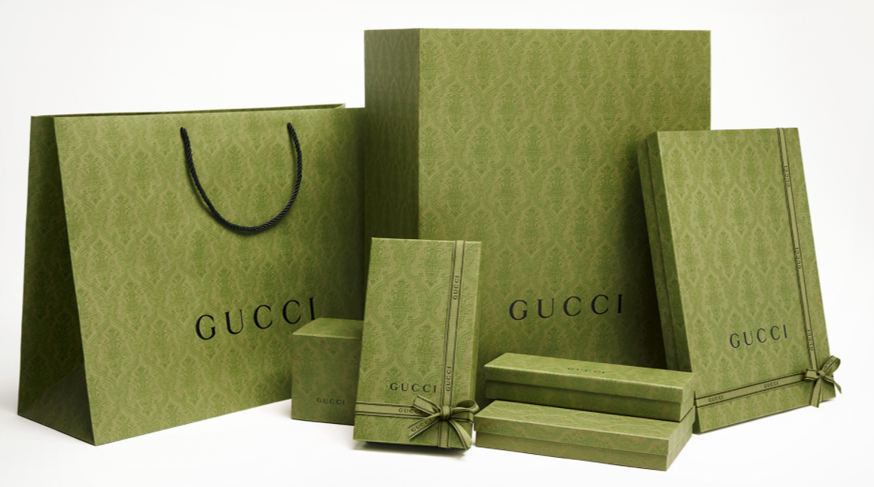  Figure 8 - Gucci's new 'Green' coloured, sustainable packaging
Yves Saint Laurent(YSL) | 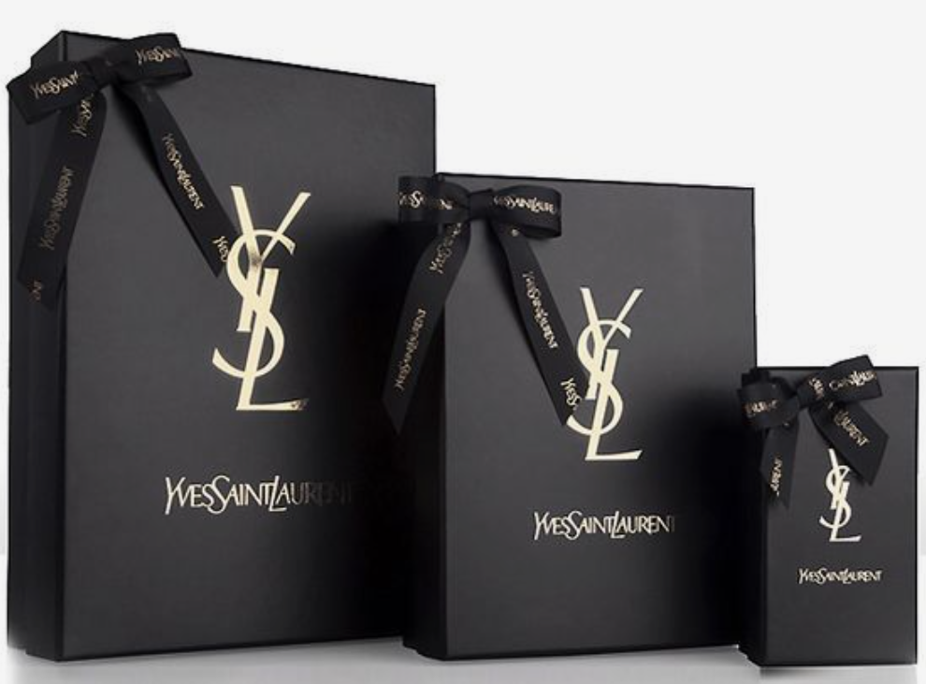  Figure 9 - Yves Saint Laurent's biodegradable packaging  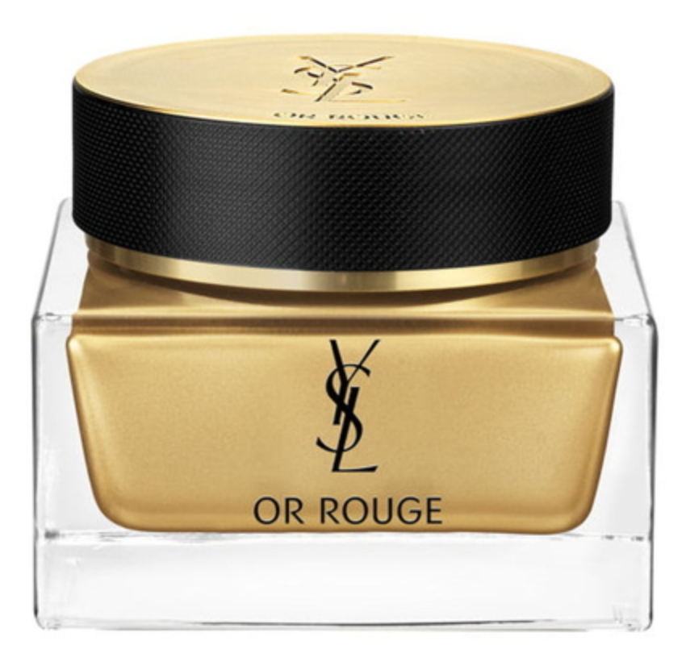  Figure 10 - YSL's refillable and eco-designed packaging
Girard Perregaux | 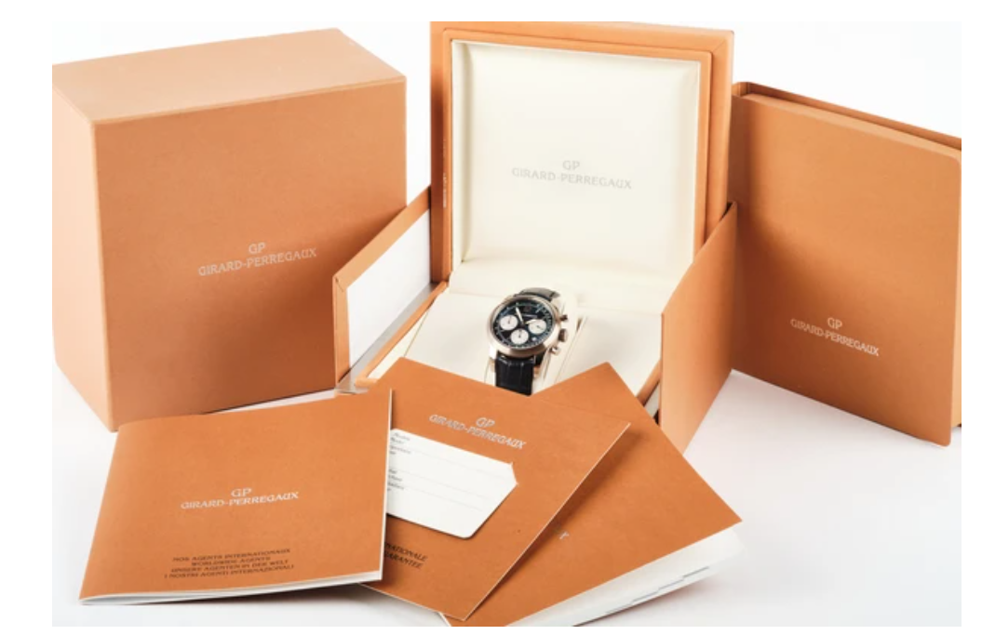  Figure 11 - Girard Perregaux's lavish packaging

Price

Price is another core element of marketing-mix. Ideal pricing of luxury-goods is the one that that covers all types of costs (fixed and variable), ensures higher-profits and doesn’t negatively-affects sales-volume and branding. Kering and its brand uses premium price-skimming technique. This strategy complements the experience of buyers by providing them a sense of buying something exclusive, thus enhancing brand-positioning. Kering also launches innovated, designer and limited-collections every season, which justifies its premium-pricing. Therefore, even after lower sales-volume, Kering’s profit-margins are high, unlike other brands in non-luxury fashion-industry. Along these, some brands like Gucci also offers discount-offer time-to-time which not only increase sales but promotes word-of-mouth by selling to a comparatively poorer strata of the market, which helps in creating a buzz in less affluent strata of market as well.

Place

Kering has 1433 stores worldwide which retails luxury-goods and earns about 78% of revenue . And there’s been significant growth on its digital-platforms as well (more than a 20% online sales increased in 2019).
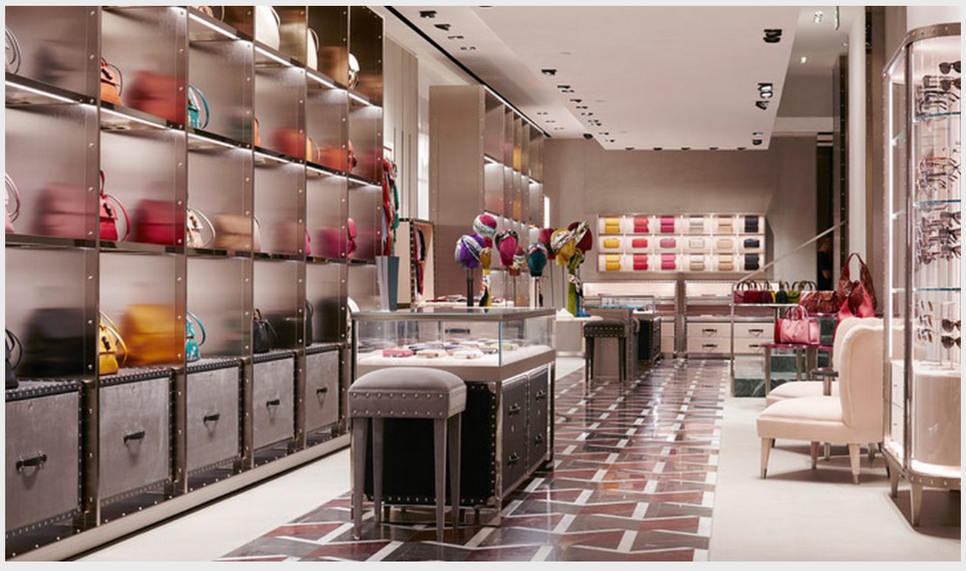
Figure 12 - Interior of Gucci Milan, Italy.

Fig.-12 depicts the aura generated at a Gucci-store. This luxury-atmosphere is maintained in every store because Kering has managed to create an image of inaccessibility for its luxury-goods by opening stores at selective developed-locations only. Therefore, not everyone can buy it, hence, promoting its luxurious-product by implying that those who purchase Kering’s luxury-goods have a higher social-status and are in an exclusive-group. Coupled with that, being a French-brand complements Kering with an upper hand across Europe (since Paris is known as ‘The Fashion Capital of World’). The stores are opened where there is higher footfall with an uptown market, constituting a lot of high-end brands, making it easier for the store to become a popular shopping-landmark, thus enhancing Kering’s market-positioning.

In overall, this type of place-branding makes the brand visible to potential-customer, however, it is has an antithetical-effect as well because of availability of various-choices for customers to choose from, thus intensifying competition.

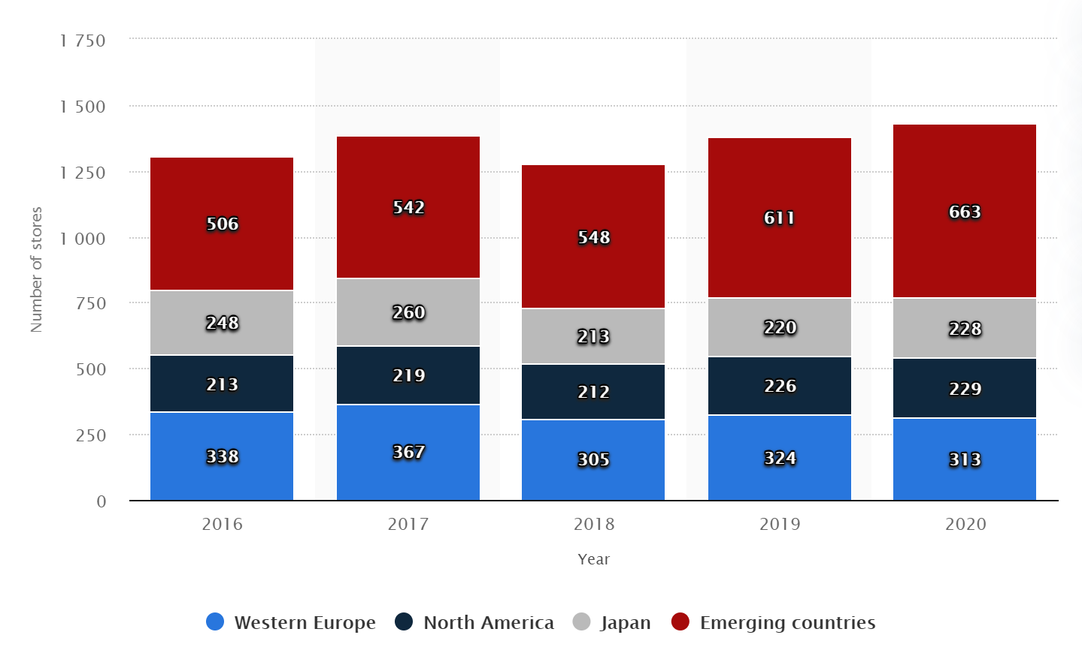
Figure 13 - Directly operated Kering stores region-wise

Promotion

Kering has taken a very strategic-approach by promoting its brands using below-the-line promotional-techniques (ex.-branding, slogans, logos, packaging, word-of-moth, publicity etc.) instead of heavily promoting through above-the-line promotion like other brands in fashion-industry.
Kering also makes general public cognizant of its luxury-houses by enticing them with high-quality, uniquely-designed, expensive image of luxury-goods. It’s vision – “Embracing creativity for a modern, bold vision of Luxury” and strategy – “Harnessing the full potential of luxury to grow faster than our markets” appeals promising to stakeholders making the brands trustable, which leaves a deep-imprint in their minds. Some elements analysed in this section are derived from a trade journal cited in footnote.

STP (Segmenting-Targeting-Positioning) Framework Practice

STP Framework is an audience-focused (rather than product-focused) approach that helps in marketing a product to the most appropriate segments that are profitable.
Market-Segmentation

Kering has segmented its market based on income-level and age-demographics.

Market-Targeting

Being a luxury holding-company, Kering targets high-income, affluent-customers with higher purchasing-power who can spend their excessive-discretionary income to buy Kering’s products adding up to its profits. There is also higher barriers to entry in luxury-industry, reducing competition. In addition, the industry’s growth-rate(pre-pandemic) is also rising every year.

Brand/Product Positioning

Kering has managed to successfully position its brands and products in the market which can be seen with its increasing revenue and popularity almost every-year and enhanced brand-perception amidst its competitors.

This model clarifies the market Kering and its brands are operating which now justifies its strategies that Kering has been executing by catering for a niche-market consisting high-profile customers with an elevated status-quo. However, this model doesn’t acknowledges that segments can overlap and even comparatively poorer-segment buys from Kering’s brands now and then due to enhanced market-position of Kering’s products as social-status definer.

Market-positioning method

The major methods are as follows:

Method | Steps-Taken/Current-Situation
International-promotion (across Europe) | Multiple celebrity-endorsements and seasonal fashion-shows.  There’s only one Central-bank(European-Union) for entire Europe thus, there are generally lesser:  - Language  - Political  - Economic  - Cultural differences  Hence, easing promotional-techniques across Europe.
E-Platform | - Increasing online-market  - Followers  Balenciaga – 1.9million Facebook, 11.6million Instagram  Gucci – 43.2million Instagram  Alexander McQueen –10.6miilion Instagram  - Saint-Laurent and Gucci are most popular over twitter too.  - Safer payment method increased reliability to buy from
CSR & Ethical-Objectives | - Only luxury-group included in ‘A’ List with CDP (Carbon-Disclosure-Project)  - Achieved Carbon-Neutrality  - Provides 14weeks paid-leave to employees who are parents of a new-born child.  - 55% Women-managers  - Gucci banned animal-fur in its goods  - Balenciaga launched eco-friendly collection  - Gucci frequently donates millions of dollars to UNICEF and has a Gucci-UNICEF partnership supporting over 7.5million children

In overall, marketing-mix proves that Kering promotes its brands in a sustainable-way, reducing its carbon-footprint and heavily benefits from its e-platform that enhances its customer-positioning while the international promotion enhances its market-positioning. However, due to recent-highlights of pandemic, the marketing-mix didn’t effectively reflected upon impact of pandemic over luxury-industry.

Industry Analysis

Major elements luxury fashion-industry are explored to get substantial conclusions. The insights of industry-analysis will help in understanding whether Kering’s strategies executed effectively enough to enhance its market-position.

Impact of pandemic and measures taken

Information is taken from Kering’s 2020 Financial report.
 | Impact on industry | Measures and initiatives taken by Kering to maintain its position in market
Manufacture, designs logistics and supply | Low-productivity at production-units after lockdown.  Calendar for collections and deliveries got delayed  Designing and merchandising procedures adversely-impacted because of lockdown-measures. | Adaptations of calendar and format of fashion-shows.  Resumption of logistics-activities by amending adjustments to delivery-flows based on postponement of collections and store-reopening.  Accelerated digitalization of marketing and product-designing with virtual sales-campaigns.
Distribution & clients | Partial/Complete closure of stores. | Planned internalization of online-capacities for Saint Laurent and Alexander McQueen.  Extensive focus on enhancing e- platform. As a result, 23% of revenue (highest recorded yet) came from online-sales.
Stakeholders | Suppliers and economic-stakeholders adversely affected due to lockdown-measures reducing sales. This halted release of seasonal-collections and delayed production-calendar by months too affecting employees and production-units too. | Implementation of strict-measures ensuring safety and health of employees, clients and suppliers.  Making employees work-from-home for some time.  Masks produced by the house.  Gucci-San Paolo agreement, an initiative supporting suppliers.  Jobs protected and salary-levels of employees maintained.
Financial | Market down by 22.77% (64-billion Euros) as compared to year-2019. | Revenue-optimization measures via distance-selling, online-sales and adjustments to collections.  Prioritized-investment with strategic-programs continued in internalization of E-commerce, information-systems and logistics.  No significant escalation of sufficient liquidity and credit-risks across the group (confirmed bond-issue and credit-lines).

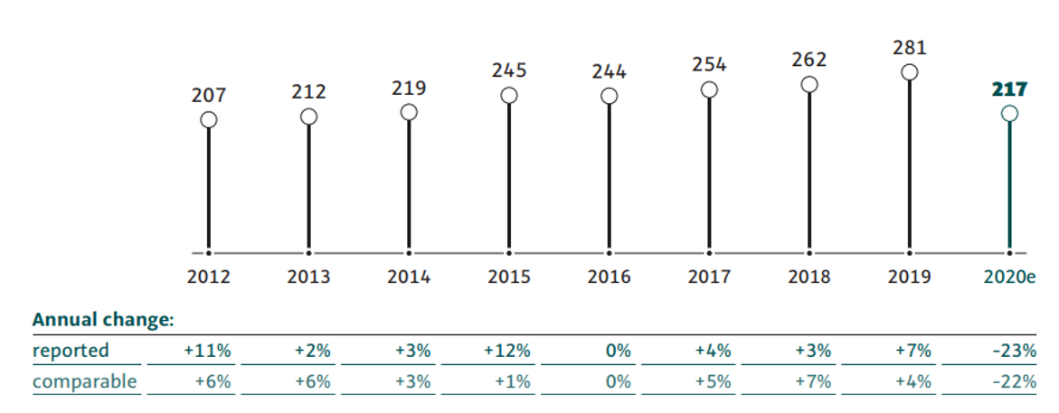
Figure 14 - Year-wise value of personal luxury-goods market (in billion euros).

Financial View

Market-Share Analysis

Kering’s market-share has been consistently increasing with a stable growth-rate since the last 4 years as seen in Fig.–15. The values here are calculated by using information from Fig.–14 and Appendix 3.3. This proves that Kering’s premium-brands are successful in ameliorating Kering’s market-positioning effectively.

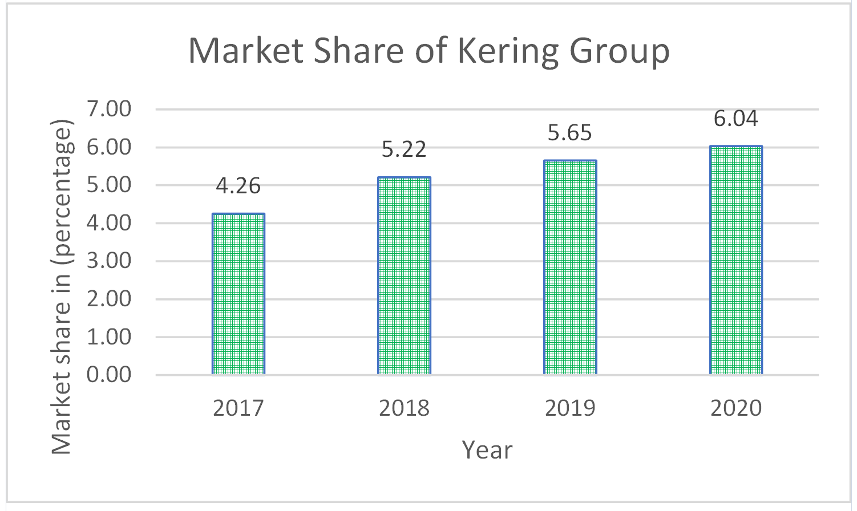
Figure 15 - Year-wise market share of Kering

Revenue Analysis

Fig.– 16 depicts increasing revenue of Kering and its brands every-year. Increasing revenue is generally a result of increasing sales. And increasing sales implies an increasing customer-base. This means that Kering has been able to successfully increase its customer-base every-year which helps in enhancing its market-position.
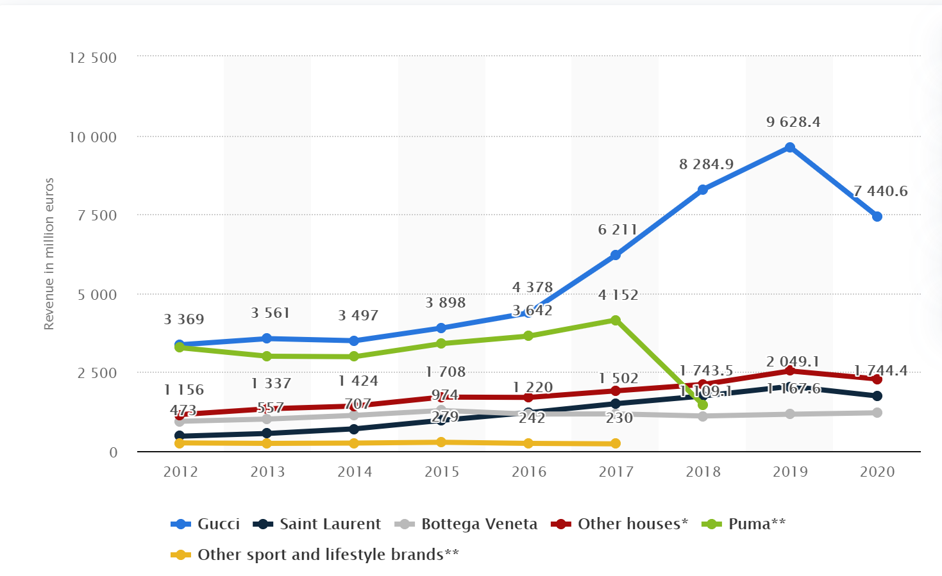
Figure 16 - Brand wise Revenue of Kering's brands

Conclusion

To conclude, Kering has successfully differentiated itself from its competitors in the luxury-fashion industry through its luxury-brands as discussed in intangible-asset-valuation. The extensive investment in CSR and ethical-objectives is not only creating an ideal organisational-culture but is also helping Kering to enhance its financial-position in the industry (industry-analysis). The pricing, placing, branding and promotional-strategies (marketing-mix) of Kering together ameliorates its exclusiveness and stakeholder’s perspective towards the organisation, which is something very essential for enhancing market-positioning of a luxury-brand. Even after closure of stores during the two lockdowns in Europe (one in March and another in November), Kering has been able to improve its market-share and enhance its distribution-channel by focusing more on E-commerce, however it would be harder to maintain if the pandemic extends because industry these months is very dynamic (due to pandemic) making it difficult to speculate upcoming threats and demand-fluctuations.
One of the limitations of this essay is that the primary-research was conducted in an Indian-store, instead of an European-store because of geographical-constrains. Another limitation is that the cultural-differences (in international-promotion across Europe) weren’t explored to a substantial extent due to lack of European cultural-knowledge. There’s also possibility that the financial-information used in the essay may not be accurate and include decorated-figures due to conflicting data on internet. However, the bias was reduced to a significant extent by verifying from various varied and trusted sources. The essay also considered only the major-competitor of Kering i.e. LVMH and didn’t analysed roles of other competitors like Burberry, Richemont, Prada etc impeding upon the competitor-analysis. All this would’ve helped me in gaining better insights about various other elements of Kering’s established market-positioning.

Works Cited
- NYSE. Global Journal of Management And Business Research, New York Stock Exchange, globaljournals.org/GJMBR_Volume12/E-journal_GJMBR_Vol_12_Issue_12_July.pdf.
- Hoang, Paul. Business Management 4th Edition. IBID Press, 2018.
- Gilligan Colin, Wilson Richard. Strategic Marketing Planning 2nd Edition. Butterworth-Heinemann, 2009.
- Kering – Financial document 2019 https://keringcorporate.dam.kering.com/m/5950e4d285ac1f9a/original/2019-Financial-Document.pdf
- Robertson, Mackenzie. “Celine Brand Extension.” http://mackenzierobertson.com/celine-brand-extension.
- Kering. “KERING Document Financier 2020 Production UK.” KERING_Document_Financier_2020_Production_UK, Kering, keringcorporate.dam.kering.com/m/57a7ad2619884844/original/KERING_Document_Financier_2020_Production_UK.pdf.
- Socha, Miles. “Kering, Balenciaga Unveil Tranquil Headquarters - Lavender Included.” WWD, WWD, 15 Sept. 2016, wwd.com/business-news/business-features/kering-balenciaga-demna-pinault-tranquil-headquarters-gucci-michele-10546561/.
- "Group History". Kering.Com, https://www.kering.com/en/group/culture-and-heritage/group-history/.
- "The Kering Group Multi-Brand Business Model In A Nutshell - Fourweekmba". Fourweekmba, https://fourweekmba.com/kering-business-model/.
- Gunther, Caitlin Raux, et al. “Kering Shines Light on Sustainability Efforts.” Vogue Business, 30 Jan. 2020, www.voguebusiness.com/sustainability/kering-shines-light-on-sustainability-efforts-luxury.
- "Kering Eyewear". Kering.Com, https://www.kering.com/en/houses/kering-eyewear/.
- “Top 15 Most Popular Luxury Brands Online In 2020.” Luxe Digital, 22 Nov. 2020, luxe.digital/business/digital-luxury-ranking/most-popular-luxury-brands/.
- “Jackie 1961 Women's Collection: Jackie Handbags: GUCCI® US.” Jackie 1961 Women's Collection | Jackie Handbags | GUCCI® US, www.gucci.com/us/en/st/capsule/jackie-1961.
- "Why We Love Gucci". Codogirl.Com, https://www.codogirl.com/blogs/news/why-we-love-gucci.
- “Gucci Bags Prized by Women the World Over; Italian Concern Has Been in Family for 59 Years.” The New York Times, The New York Times, 7 Oct. 1964, www.nytimes.com/1964/10/07/archives/gucci-bags-prized-by-women-the-world-over-italian-concern-has-been.html.
- "Care: Environmental Responsibility". Kering.Com, https://www.kering.com/en/sustainability/our-strategy/care/.
- Davis, Dominic-Madori. “LVMH Just Offered to Buy Tiffany & Co - Here's a Look at 17 of the Most Iconic Brands the French Luxury Giant Owns.” Business Insider, 29 Oct. 2019, www.businessinsider.in/thelife/news/lvmh-just-offered-to-buy-tiffany-co-160heres-a-look-at-17-of-the-most-iconic-brands-the-french-luxury-giant-owns/articleshow/71809645.cms.
- “Key Figures by Business and Region, Income Statement - LVMH Group.” LVMH, www.lvmh.com/investors/profile/financial-indicators/#groupe.
- "Introducing Gucci’S New Sustainable Packaging – Gucci Equilibrium". Equilibrium.Gucci.Com, https://equilibrium.gucci.com/introducing-guccis-new-sustainable-packaging/.
- image. 2021, "Yves Saint Laurent . . . Father's Day Special 15% OFF! FREE Shipping! Use Code: DAD16 At Checkout! Http://Kerlagons.Auths… | Luxury Box Packaging, Packaging, Gifts". Pinterest, 2021, https://br.pinterest.com/pin/246220304611749194/. Accessed 9 Mar 2021.
- "Albéa: A Refillable And Eco-Designed Packaging For Yves Saint Laurent Or Rouge". Premium Beauty News, https://www.premiumbeautynews.com/en/albea-a-refillable-and-eco,14774.
- “Girard Perregaux 4956.” Swiss Watch & Diamond Exchange, Inc., swisswatch.net/products/girard-perregaux-4956.
- "Milan Fashion Boutiques: Gucci Unveils New Store Concept". Milandesignagenda.Com, https://www.milandesignagenda.com/milan-fashion-boutiques-gucci-unveils-new-store-concept/.
- "The Kering Group: Number Of Luxury Division Stores By Region Worldwide 2020 | Statista". Statista, https://www.statista.com/statistics/914931/number-of-kering-group-luxury-division-stores-worldwide-by-region/#:~:text=Number%20of%20Kering%20Group%20luxury,2016%20to%202020%2C%20by%20region&text=In%20the%20year%202020%2C%20the,goods%20stores%20worldwide%20that%20year.
- “Group Profile and Vision.” Kering, www.kering.com/integrated-report-2020/en/profil-et-vision/#:~:text=KERING%27S%20VISION%3A%20EMBRACING%20CREATIVITY%20FOR,on%E2%80%9D%20consumers%20seek%20meaningful%20connections.
- “Business Model and Strategy.” Kering, www.kering.com/integrated-report-2020/en/business-model-et-strategie.
- https://www.facebook.com/Balenciaga/
- https://www.instagram.com/balenciaga/?hl=en
- https://www.instagram.com/gucci/?hl=en(----)
- https://www.instagram.com/alexandermcqueen/(-----)
- Kering. “Kering Named on CDP 'A List' for Leading Effort against Climate Change for the 3rd Consecutive Year.” Kering, Kering, 20 Jan. 2020, www.kering.com/en/news/kering-named-on-cdp-a-list-for-leading-effort-against-climate-change-for-the-3rd-consecutive-year.
- Kering. “Kering to Provide 14 Weeks of Paid Baby Leave to All Parents of a New Child.” Kering, Kering, 10 Sept. 2019, www.kering.com/en/news/kering-to-provide-14-weeks-of-paid-baby-leave-to-all-parents-of-a-new-child.
- "BREAKING: Gucci Bans Angora Wool Following PETA Appeal | PETA". PETA, https://www.peta.org/blog/gucci-bans-fur/.
- "Balenciaga Just Launched A New Eco-Friendly Collection, Doing Their Bit For Sustainability Of Fashion | PINKVILLA". Pinkvilla.Com, https://www.pinkvilla.com/fashion/style-tips/balenciaga-just-launched-new-eco-friendly-collection-doing-their-bit-sustainability-fashion-439724.
- "Gucci-UNICEF Partnership Turns 10: Over 7.5 Million Children Reap Rewards". UNICEF, https://www.unicef.org/media/media_82165.html.
- "Global Revenue Of The Kering Group, By Brand 2020 | Statista". Statista, 2021, https://www.statista.com/statistics/267476/global-revenue-of-the-kering-group-by-brand/.
- Development, Daisy. “Jennifer Lopez - Gucci.” Jennifer Lopez Singer - Gucci : Celebrity Endorsements, Celebrity Advertisements, Celebrity Endorsed Products, www.celebrityendorsementads.com/celebrity-endorsements/celebrities/jennifer-lopez/gucci/.
- Development, Daisy. "Chris Evans Actor - Celebrity Endorsements, Celebrity Advertisements, Celebrity Endorsed Products". Celebrityendorsementads.Com, http://www.celebrityendorsementads.com/celebrity-endorsements/celebrities/chris-evans/.
- Development, Daisy. "Yves Saint Laurent Libre Yves Saint Laurent Libre New Perfume Guide". Theperfumegirl.Com, http://www.theperfumegirl.com/perfumes/fragrances/yves-saint-laurent/ysl-libre/.
- "Kristen Stewart Bares All In Balenciaga's New Perfume Ad". India Today, https://www.indiatoday.in/movies/hollywood/story/kristen-stewart-balenciaga-rosabotanica-florabotanica-twilight-robert-pattinson-175858-2014-01-07.
- Development, Daisy. "Balenciaga Florabotanic Floral Green Perfume, Kristen Stewart - New Fragrance For Women". Theperfumegirl.Com, http://www.theperfumegirl.com/perfumes/fragrances/balenciaga/balenciaga-florabotanica/.
- "Gucci Collections - Gucci Runway Show Archive". ELLE, https://www.elle.com/gucci-runway/.
- Nast, Condé. "Gucci News, Collections, Fashion Shows, Fashion Week Reviews, And More". Vogue, 2021, https://www.vogue.com/fashion-shows/designer/gucci.
- "Value Of The Online Personal Luxury Goods Market Worldwide 2020 | Statista". Statista, https://www.statista.com/statistics/246133/value-of-the-online-personal-luxury-goods-market-worldwide/.
- BLOG, NEWS. "Fashion United Twitter Fashion Index - APLF.Com". Aplf.Com, 2021, http://www.aplf.com/en-us/leather-fashion-news-and-blog/news/9172/fashion-united-twitter-fashion-index.
- "Celebrities Who Wear Gucci". Ranker, https://www.ranker.com/list/celebrities-who-wear-gucci/reference.
- "Celebrities Who Wear Balenciaga". Ranker, https://www.ranker.com/list/celebrities-who-wear-balenciaga/reference.
- "Boucheron – Celebrities Wearing Creations At Cannes Film Festival". Luxsure, https://www.luxsure.fr/2019/06/02/boucheron-celebrities-wearing-creations-at-cannes-film-festival/.

Appendices

Appendix 1 – Celebrities Endorsements of Kering’s Brands
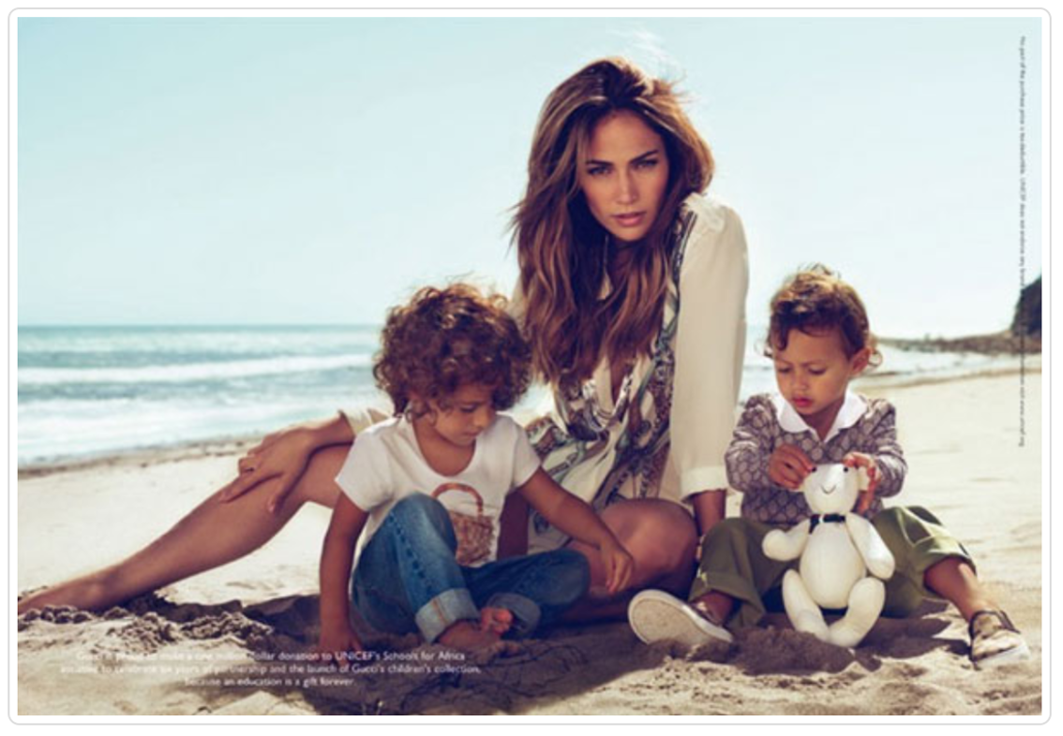
Development, Daisy. “Jennifer Lopez - Gucci.” Jennifer Lopez Singer - Gucci : Celebrity Endorsements, Celebrity Advertisements, Celebrity Endorsed Products, www.celebrityendorsementads.com/celebrity-endorsements/celebrities/jennifer-lopez/gucci/.
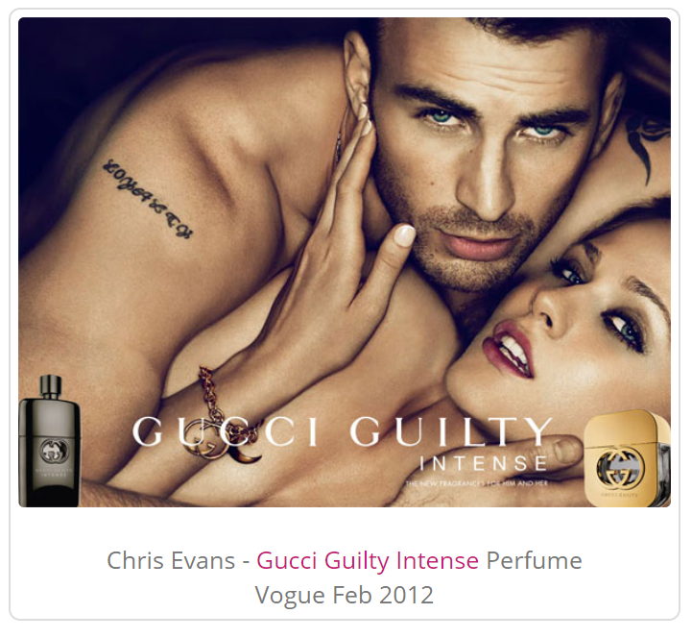
Development, Daisy. "Chris Evans Actor - Celebrity Endorsements, Celebrity Advertisements, Celebrity Endorsed Products". Celebrityendorsementads.Com, http://www.celebrityendorsementads.com/celebrity-endorsements/celebrities/chris-evans/.
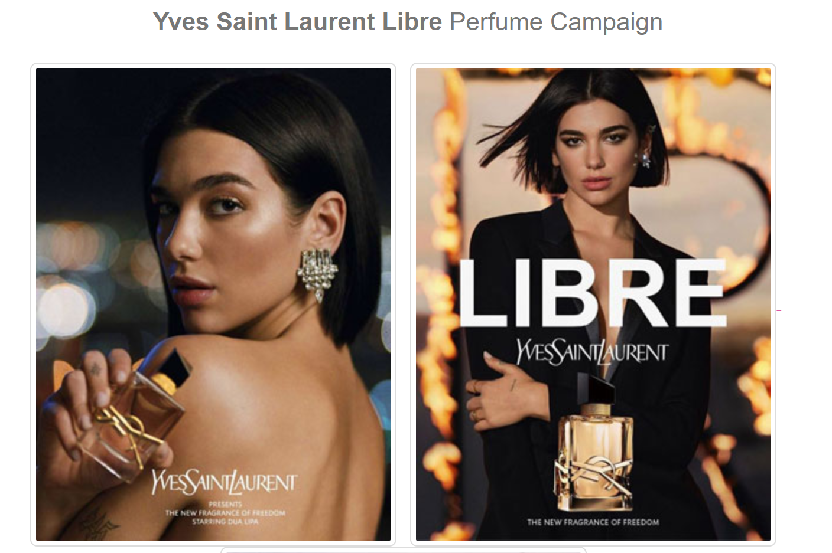
Development, Daisy. "Yves Saint Laurent Libre Yves Saint Laurent Libre New Perfume Guide". Theperfumegirl.Com, http://www.theperfumegirl.com/perfumes/fragrances/yves-saint-laurent/ysl-libre/.
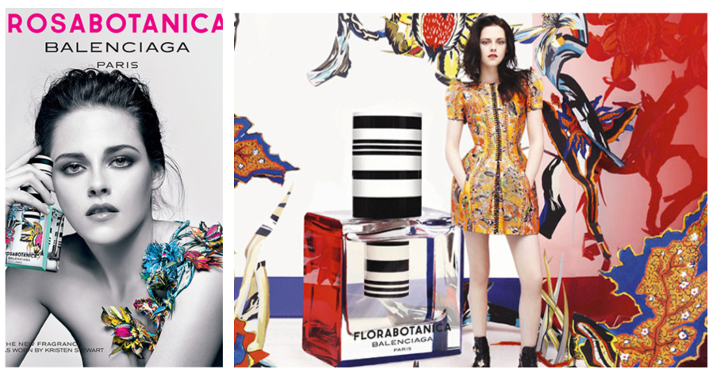
"Kristen Stewart Bares All In Balenciaga's New Perfume Ad". India Today, https://www.indiatoday.in/movies/hollywood/story/kristen-stewart-balenciaga-rosabotanica-florabotanica-twilight-robert-pattinson-175858-2014-01-07.
Development, Daisy. "Balenciaga Florabotanic Floral Green Perfume, Kristen Stewart - New Fragrance For Women". Theperfumegirl.Com, http://www.theperfumegirl.com/perfumes/fragrances/balenciaga/balenciaga-florabotanica/
"Gucci Collections - Gucci Runway Show Archive". ELLE, https://www.elle.com/gucci-runway/.

Appendix 2 – Some seasonal collections of Gucci (a Kering brand)

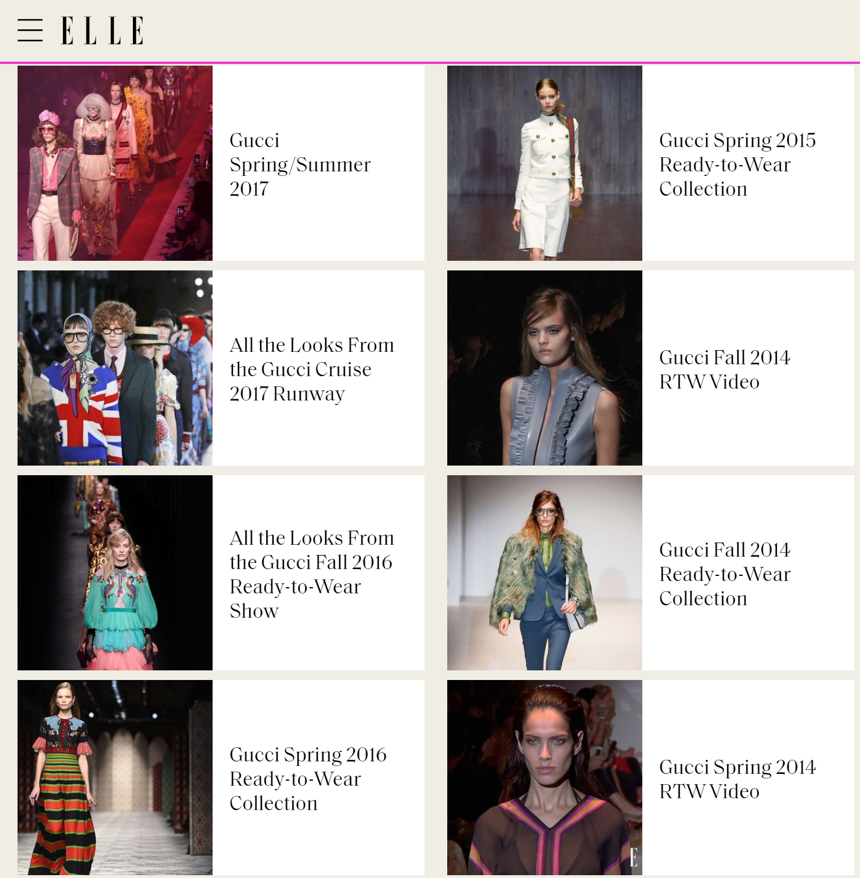
"Gucci Collections - Gucci Runway Show Archive". ELLE, https://www.elle.com/gucci-runway/.

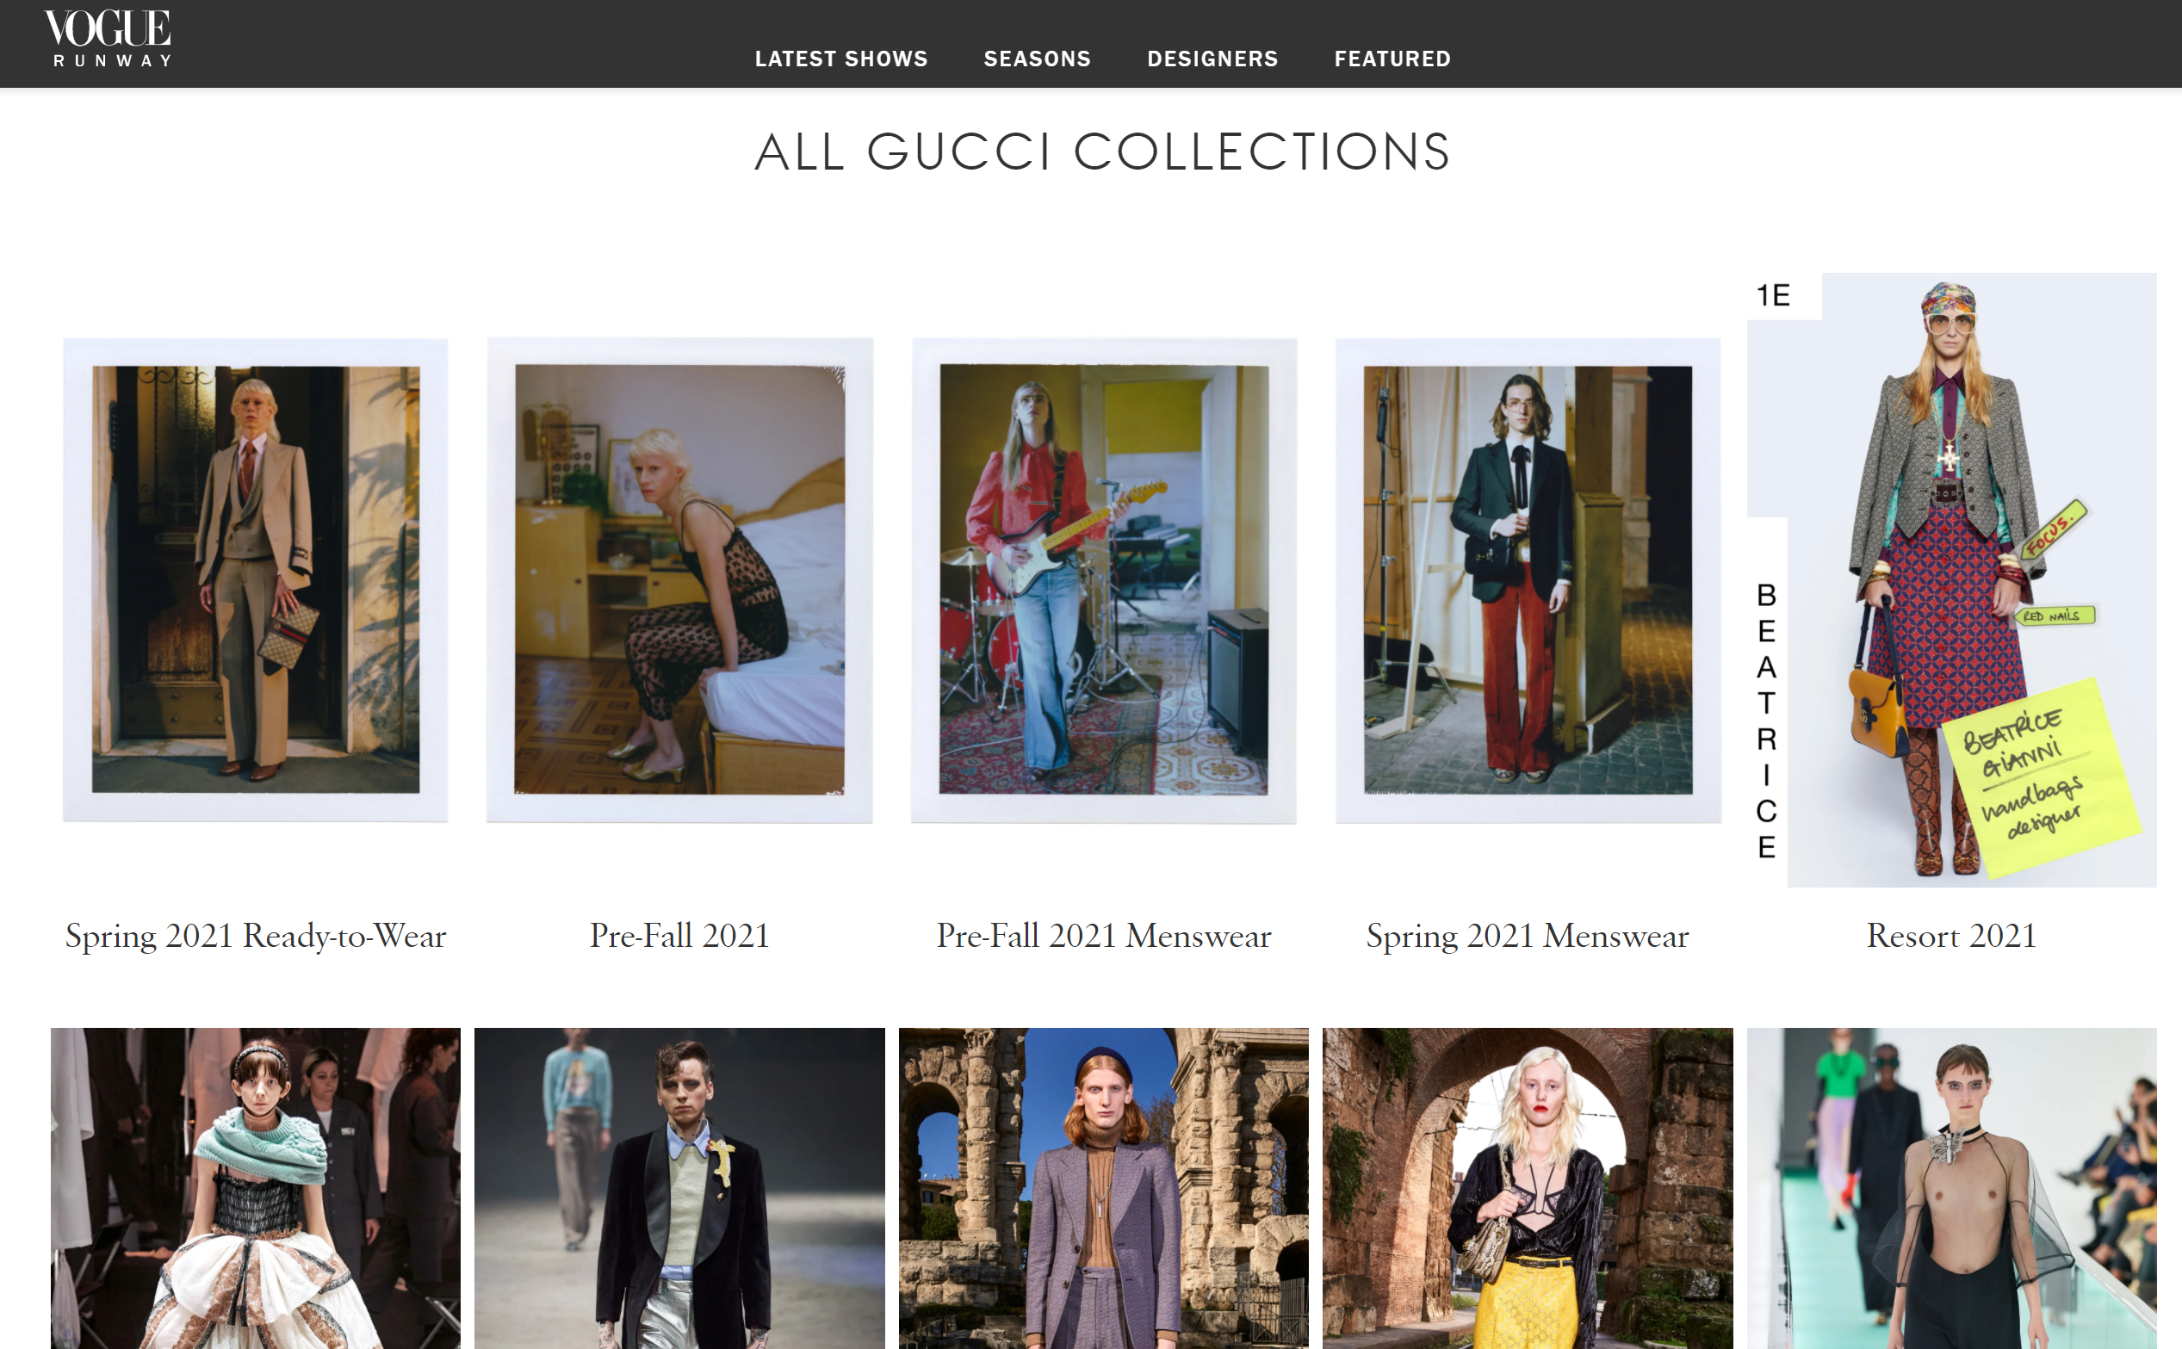
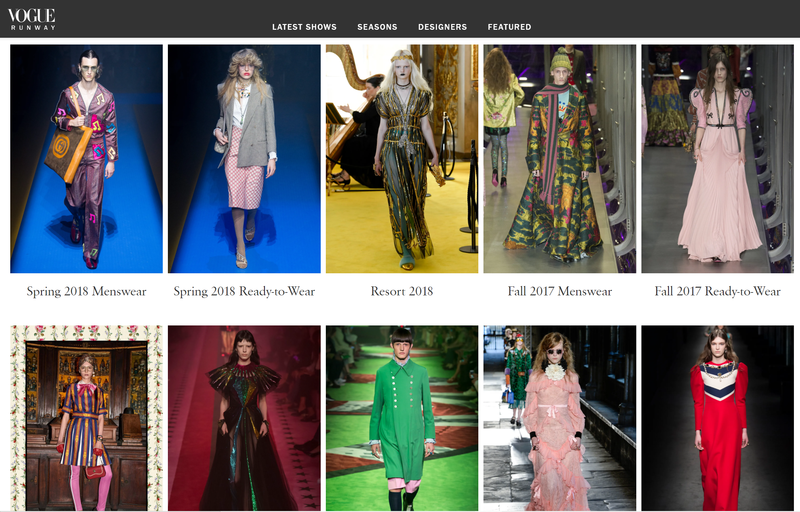
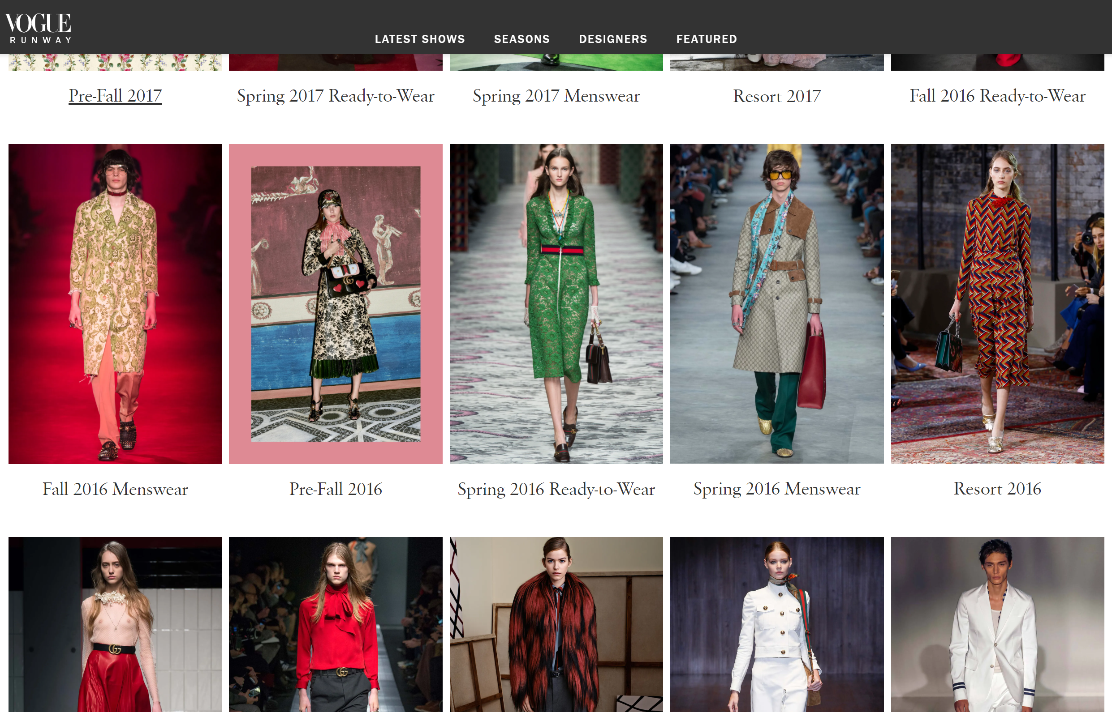
Nast, Condé. "Gucci News, Collections, Fashion Shows, Fashion Week Reviews, And More". Vogue, 2021, https://www.vogue.com/fashion-shows/designer/gucci.

Appendix 3 – Factual Figures

Appendix 3.1 – Consolidated income statement (year ending Dec, 2019 & 2018)
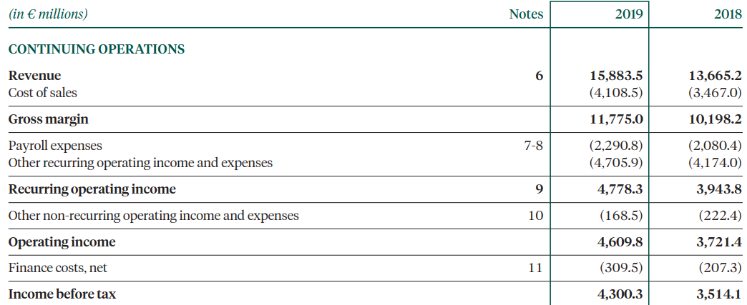
Kering – Financial document 2019 https://keringcorporate.dam.kering.com/m/5950e4d285ac1f9a/original/2019-Financial-Document.pdf

Appendix 3.2 – Social Media presence

Increasing value of online luxury-goods market worldwide (as of 2020)
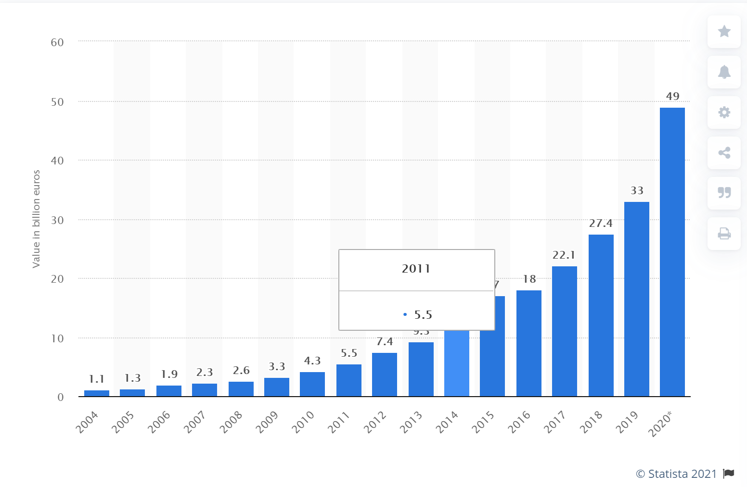
"Value Of The Online Personal Luxury Goods Market Worldwide 2020 | Statista". Statista, https://www.statista.com/statistics/246133/value-of-the-online-personal-luxury-goods-market-worldwide/.

Most popular Twitter pages
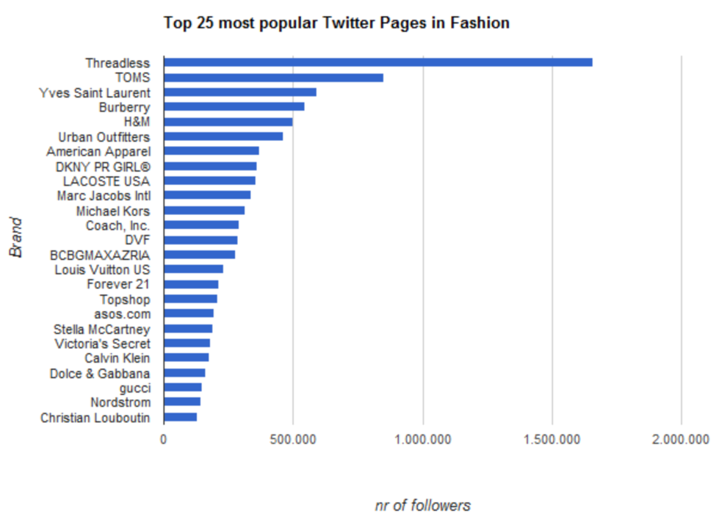
BLOG, NEWS. "Fashion United Twitter Fashion Index - APLF.Com". Aplf.Com, 2021, http://www.aplf.com/en-us/leather-fashion-news-and-blog/news/9172/fashion-united-twitter-fashion-index.

Appendix 3.3 – Year-wise revenue of Kering

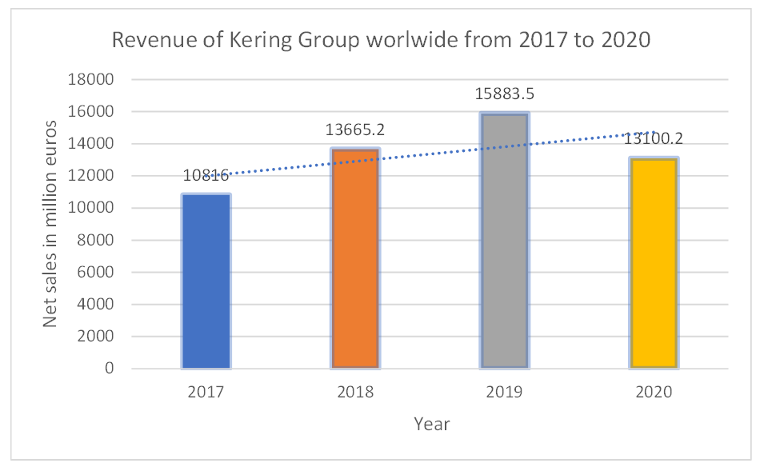
"Kering Group: Revenue Worldwide 2020 | Statista". Statista, 2021, https://www.statista.com/statistics/267466/global-revenue-of-the-kering-group/.

Appendix 4 – Kering’s brands basic background
Country of Origin | Brand | Year founded | Field
Italy | Gucci | 1999 | Luxury fashion house
France | Yves Saint Laurent | 1999 | Luxury fashion house
France | Boucheron | 2000 | Luxury Jewellery
Italy | Bottega Veneta | 2001 | Luxury fashion house
Spain | Balenciaga | 2001 | Luxury fashion house
UK | Alexander McQueen | 2001 | Luxury fashion house
Italy | Brioni | 2011 | Menswear couture house
Swiss | Girard-Perregaux | 2011 | Watch manufacture
Swiss | Jean Richard | 2011 | Watch manufacture
Hong Kong SAR, China | Qeelin | 2012 | Luxury Jewellery
Italy | Pomellato | 2012 | Luxury Jewellery
Italy | Dodo | 2012 | Luxury Jewellery
Swiss | Ulysse Nardin | 2014 | Luxury watchmaking

Appendix 5 – Publicity

Appendix 5.1 – Renowned Celebrities who buys Kering’s Brands
Kering’s brand name |  | Celebrity name
Gucci |  | Rihanna  Blake Lively  Brad Pitt  Salma Hayek | Drew Barrymore  Rachel McAdams  Kate Moss  Lil Wayne
Balenciaga |  | Beyoncé Knowles  Gwyneth Paltrow | Kristen Stewart  Kevin Jonas
Boucheron |  | Marina Foïs  Géraldine Nakache  Mila Jovovich | Laure Calamy  Virginie Ledoyen  Aurélie Dupont
Gucci | "Celebrities Who Wear Gucci". Ranker, 2021, https://www.ranker.com/list/celebrities-who-wear-gucci/reference.
Balenciaga | "Celebrities Who Wear Balenciaga". Ranker, 2021, https://www.ranker.com/list/celebrities-who-wear-balenciaga/reference.
Boucheron | "Boucheron – Celebrities Wearing Creations At Cannes Film Festival". Luxsure, 2021, https://www.luxsure.fr/2019/06/02/boucheron-celebrities-wearing-creations-at-cannes-film-festival/. Accessed 9 Mar 2021.

Appendix 5.2 – Popular Songs on Kering’s Brands

Song name | Artist(s)/Group name | Kering Brand addressed in song
Gucci Gang | Lil Pump | Gucci
Gucci’an Di Lod Ni Tu Chahida | Aroob Khan | Gucci
Guccci | Aarsh Benipal | Gucci
Skechers | Drip Report & Tyga | Gucci
Balenciaga | Halsey | Balenciaga
Balenciaga | Lil Golu, Shevy | Balenciaga
Gucci Gucci | Kreayshawn | Gucci
Gucci Bandana | Soulija Boy | Gucci
Gucci Everything | Red Cafe | Gucci
Gucci, Louis, Prada | Twista | Gucci
Saint Laurent | DJ Sliink, Skrillex, Wale | Saint Laurent
Gucci This (Gucci That) | Teen girl group – OMG Girlz | Gucci

Socha, Miles. “Kering, Balenciaga Unveil Tranquil Headquarters - Lavender Included.” WWD, WWD, 15 Sept. 2016, wwd.com/business-news/business-features/kering-balenciaga-demna-pinault-tranquil-headquarters-gucci-michele-10546561/.
"Group History". Kering.Com, https://www.kering.com/en/group/culture-and-heritage/group-history/.
Hoang, Paul. Business Management 4th Edition. IBID Press, 2018.
Gilligan Colin, Wilson Richard. Strategic Marketing Planning 2nd Edition. Butterworth-Heinemann, 2009.
Appendix 2 – Some seasonal collections of Gucci (a Kering brand)
Fig. 1 - Kering and its Brand's Logos
Fig. 12 - Interior of Gucci Milan, Italy
"The Kering Group Multi-Brand Business Model In A Nutshell - Fourweekmba". Fourweekmba, https://fourweekmba.com/kering-business-model/.
Twitter graph
Appendix 2 – Some seasonal collections of Gucci (a Kering brand)
Appendix 1 – Celebrities Endorsements of Kering’s brands
Gunther, Caitlin Raux, et al. “Kering Shines Light on Sustainability Efforts.” Vogue Business, 30 Jan. 2020, www.voguebusiness.com/sustainability/kering-shines-light-on-sustainability-efforts-luxury.
"Kering Eyewear". Kering.Com, https://www.kering.com/en/houses/kering-eyewear/.
“Top 15 Most Popular Luxury Brands Online In 2020.” Luxe Digital, 22 Nov. 2020, luxe.digital/business/digital-luxury-ranking/most-popular-luxury-brands/.
Appendix 1 and Appendix 5
Kering – Financial document 2019 https://keringcorporate.dam.kering.com/m/5950e4d285ac1f9a/original/2019-Financial-Document.pdf
Fig. 3 – Gucci's beloved 'The Jackie 1961' handbags
“Jackie 1961 Women's Collection: Jackie Handbags: GUCCI® US.” Jackie 1961 Women's Collection | Jackie Handbags | GUCCI® US, www.gucci.com/us/en/st/capsule/jackie-1961.
Fig. 4 – Consolidated Non-current assets of Kering (December 31, 2019 & 2018)
Kering – Financial document 2019 https://keringcorporate.dam.kering.com/m/5950e4d285ac1f9a/original/2019-Financial-Document.pdf
"Why We Love Gucci". Codogirl.Com, https://www.codogirl.com/blogs/news/why-we-love-gucci.
“Gucci Bags Prized by Women the World Over; Italian Concern Has Been in Family for 59 Years.” The New York Times, The New York Times, 7 Oct. 1964, www.nytimes.com/1964/10/07/archives/gucci-bags-prized-by-women-the-world-over-italian-concern-has-been.html.
"Care: Environmental Responsibility". Kering.Com, https://www.kering.com/en/sustainability/our-strategy/care/.
Appendix 4 – Kering’s brands basic background
Appendix 4 – Kering’s brands basic background
Robertson, Mackenzie. “Celine Brand Extension.” http://mackenzierobertson.com/celine-brand-extension.
Davis, Dominic-Madori. “LVMH Just Offered to Buy Tiffany & Co - Here's a Look at 17 of the Most Iconic Brands the French Luxury Giant Owns.” Business Insider, 29 Oct. 2019, www.businessinsider.in/thelife/news/lvmh-just-offered-to-buy-tiffany-co-160heres-a-look-at-17-of-the-most-iconic-brands-the-french-luxury-giant-owns/articleshow/71809645.cms.
Kering – Financial document 2019 https://keringcorporate.dam.kering.com/m/5950e4d285ac1f9a/original/2019-Financial-Document.pdf
“Key Figures by Business and Region, Income Statement - LVMH Group.” LVMH, www.lvmh.com/investors/profile/financial-indicators/#groupe.
Kering – Financial document 2019 https://keringcorporate.dam.kering.com/m/5950e4d285ac1f9a/original/2019-Financial-Document.pdf
"Introducing Gucci’S New Sustainable Packaging – Gucci Equilibrium". Equilibrium.Gucci.Com, https://equilibrium.gucci.com/introducing-guccis-new-sustainable-packaging/.
image. 2021, "Yves Saint Laurent . . . Father's Day Special 15% OFF! FREE Shipping! Use Code: DAD16 At Checkout! Http://Kerlagons.Auths… | Luxury Box Packaging, Packaging, Gifts". Pinterest, 2021, https://br.pinterest.com/pin/246220304611749194/. Accessed 9 Mar 2021.
"Albéa: A Refillable And Eco-Designed Packaging For Yves Saint Laurent Or Rouge". Premium Beauty News, https://www.premiumbeautynews.com/en/albea-a-refillable-and-eco,14774.
“Girard Perregaux 4956.” Swiss Watch & Diamond Exchange, Inc., swisswatch.net/products/girard-perregaux-4956.
Appendix 2 – Some seasonal collections of Gucci (a Kering brand)
Fig. 13 – Directly operated Kering stores region-wise
Kering – Financial document 2019 https://keringcorporate.dam.kering.com/m/5950e4d285ac1f9a/original/2019-Financial-Document.pdf
"Milan Fashion Boutiques: Gucci Unveils New Store Concept". Milandesignagenda.Com, https://www.milandesignagenda.com/milan-fashion-boutiques-gucci-unveils-new-store-concept/.
"The Kering Group: Number Of Luxury Division Stores By Region Worldwide 2020 | Statista". Statista, https://www.statista.com/statistics/914931/number-of-kering-group-luxury-division-stores-worldwide-by-region/#:~:text=Number%20of%20Kering%20Group%20luxury,2016%20to%202020%2C%20by%20region&text=In%20the%20year%202020%2C%20the,goods%20stores%20worldwide%20that%20year.
“Group Profile and Vision.” Kering, www.kering.com/integrated-report-2020/en/profil-et-vision/#:~:text=KERING%27S%20VISION%3A%20EMBRACING%20CREATIVITY%20FOR,on%E2%80%9D%20consumers%20seek%20meaningful%20connections.
“Business Model and Strategy.” Kering, www.kering.com/integrated-report-2020/en/business-model-et-strategie.
NYSE. Global Journal of Management And Business Research, New York Stock Exchange, globaljournals.org/GJMBR_Volume12/E-journal_GJMBR_Vol_12_Issue_12_July.pdf.
Fig.14 – Year-wise value of personal luxury-goods market (in billion euros)
Appendix 3.1 – Consolidated income statement (year ending Dec, 2019 & 2018)
Fig. 2 – The top 15 most popular luxury brands online in 2020
Fig. 5 – Perceptual Map of major Luxury Houses
Appendix 1 – Celebrities Endorsements of Kering’s Brands
Appendix 2 – Some seasonal collections of Gucci (a Kering brand)
Appendix 3 – Factual Figures
https://www.facebook.com/Balenciaga/
https://www.instagram.com/balenciaga/?hl=en
https://www.instagram.com/gucci/?hl=en
https://www.instagram.com/alexandermcqueen/
Appendix 3 – Factual Figures
Kering. “Kering Named on CDP 'A List' for Leading Effort against Climate Change for the 3rd Consecutive Year.” Kering, Kering, 20 Jan. 2020, www.kering.com/en/news/kering-named-on-cdp-a-list-for-leading-effort-against-climate-change-for-the-3rd-consecutive-year.
Kering. “Kering to Provide 14 Weeks of Paid Baby Leave to All Parents of a New Child.” Kering, Kering, 10 Sept. 2019, www.kering.com/en/news/kering-to-provide-14-weeks-of-paid-baby-leave-to-all-parents-of-a-new-child.
Kering – Financial document 2019 https://keringcorporate.dam.kering.com/m/5950e4d285ac1f9a/original/2019-Financial-Document.pdf
"BREAKING: Gucci Bans Angora Wool Following PETA Appeal | PETA". PETA, https://www.peta.org/blog/gucci-bans-fur/.
"Balenciaga Just Launched A New Eco-Friendly Collection, Doing Their Bit For Sustainability Of Fashion | PINKVILLA". Pinkvilla.Com, https://www.pinkvilla.com/fashion/style-tips/balenciaga-just-launched-new-eco-friendly-collection-doing-their-bit-sustainability-fashion-439724.
"Gucci-UNICEF Partnership Turns 10: Over 7.5 Million Children Reap Rewards". UNICEF, https://www.unicef.org/media/media_82165.html.
Kering. “KERING Document Financier 2020 Production UK.” KERING_Document_Financier_2020_Production_UK, Kering, keringcorporate.dam.kering.com/m/57a7ad2619884844/original/KERING_Document_Financier_2020_Production_UK.pdf.
Kering. “KERING Document Financier 2020 Production UK.” KERING_Document_Financier_2020_Production_UK, Kering, keringcorporate.dam.kering.com/m/57a7ad2619884844/original/KERING_Document_Financier_2020_Production_UK.pdf.
"Global Revenue Of The Kering Group, By Brand 2020 | Statista". Statista, 2021, https://www.statista.com/statistics/267476/global-revenue-of-the-kering-group-by-brand/.

