EXTENDED ESSAY
ECONOMICS

Topic: Impact of industrial policies on the automotive sector

Research question: To what extent has the ‘Make in India’ initiative launched in 2014 affected the Indian automotive industry between 2016-2020?

Candidate code: jgc139

Session: May 2021

Word Count: 4000
Table of Contents
Introduction 3
Methodology 4
Economic theories and models 5
1. Corporate Tax cut policy 5
2. Lowering costs of production 6
3. Customs duty (tariffs) 7
4. Negative externalities of consumption 8
5. Law of demand 9
6. Linkages 9
7. Economies of scale 10
Analysis and evaluation 11
1. Impact of ‘Make in India’ policies on the automotive industry 11
a. MEIS 11
b. FAME 12
2. Impact of government policies on the automotive industry 15
a. Corporate tax cut (2019) 15
b. Bonded Manufacturing scheme on exports 17
c. Tariffs on imported products 17
d. Auto clusters 21
Policy recommendations 22
Limitations of the research 22
Conclusion 23
Bibliography 24

Introduction
Make in India is an initiative of the Government of India introduced by Prime Minister Modi.
“I want to tell the people of the whole world: Come, make in India. Come and manufacture in India. Go and sell in any country of the world, but manufacture here. We have skill, talent, discipline and the desire to do something. We want to give the world an opportunity that come, make in India,” said the Prime Minister in a speech before launching the initiative officially.
Make in India aims to increase the contribution of the manufacturing sector from 16% to 25% of the Gross Domestic Product (GDP) by 2025. It has launched many policies to promote Foreign Direct Investment (FDI), enhance skill development, protect intellectual property, develop the manufacturing sector, etc.
Make in India programme targets 25 sectors including: automobiles, automobile components, construction, defence, etc.

In this research, the impact that the initiative has had on the automotive industry was measured through a focus on some key drivers of the industry that it aims to boost such as exports, domestic sales, production and consumption of electric vehicles. In this research, the Automotive industry was taken up because it is one of the most essential drivers of economic development in India which contributes to 7.1% to India’s GDP and about 49% of India’s manufacturing GDP. In 2017-2018 India was the 6th largest producer of automobiles in the world, producing about 29 million vehicles. 4 million of them were exported. For each vehicle produced, 13 direct and indirect jobs are created for every truck, 6 for each car, 4 for each three wheeler and 1 for each 2 wheeler. Directly and indirectly the Indian automotive industry employs more than 29 million people.
India is an ideal place for multinational automobile companies planning to expand their business in Asia as a result of its efficient manpower, cost-effectiveness of operations and a fast-growing market. Due to these favourable factors India has obtained US$ 21 billion in cumulative FDI equity inflows between April and June 2019-20.

Methodology
To analyse the impact of industrial policies on production, imports and exports, the data on these factors before and after the introduction of policies were compared. The details about the policies were obtained from the ‘Make in India’ website and other government run websites. The data on value or quantity of imports, exports etc, were taken from websites specialising in statistics.
The impact of ‘Make in India’ has been analysed separately from other government policies. The section on the MEIS (Merchandise exports from India) and Bonded Manufacturing schemes assesses their impact on exports of automobiles.
The impact of tariffs was judged by using figures on imports of auto parts, and production of commercial vehicles before and after their introduction. The influence of a corporate tax cut in 2019 was derived by comparing vehicle sales in 2019 and 2020.
The impact of auto clusters could not be judged directly but economic theory and common sense in addition to looking at the growth of the Indian automotive sector over the years suggest that they have made a positive impact.
The effect of the FAME scheme (Faster Adoption and Manufacturing of (Hybrid &) Electric Vehicles) was derived by comparing the funds allocated into it with the domestic sales of electric vehicles over the last 5 years.

Economic theories and models

Corporate Tax cut policy
A corporate tax is a tax levied on the net income (profits) of a firm.
Corporate taxes cause the supply curve of firms to shift up by the amount of tax imposed. This causes the new equilibrium quantity to be lower than before at a higher price. A cut in corporate tax rates shifts the supply curve down as shown in Fig 1. A corporate tax cut benefits consumers by lowering the price of automotive and benefit the producers by increasing sales.
Price of Indian automotives
Sales of Indian automotives
S= S1- tax
S1
D
Fig 1. Supply curve shifts to the right due to tax cuts
Q1 Q
P1
P

Lowering costs of production
The costs of producing cars in India was high which led to providing incentives that shift the average total cost curve of manufacturers down from ATC to ATC1 so that they can make higher profits by selling their cars at Pe. Profits will increase from (Pe-ATC) to (Pe-ATC1). This extra revenue can be used by firms to expand to a larger scale and benefit from economies of scale. To solve this problem the government has introduced several policies such as MEIS and the Bonded Manufacturing Scheme.

Sales of Indian automotives
Price of Indian automotives

MR
D=AR
ATC
MC

ATC1
Qmax
Pe
ATC
ATC1
Fig 2. The ATC curve shifts down as a result of Industrial policies

Customs duty (tariffs)
Tariffs make it more expensive for firms to import auto parts from abroad. A tariff refers to a tax imposed by governments on goods imported from another country. Their purpose is to make commodities from foreign competitors less desirable.

Price of parts
Demand for parts
Q
Q2
Q3
Q1
Pw
Pw+t
Sd
Dd
Fig 3. Impact of tariffs on demand of imported parts
With the tariff, Indian producers may choose to not import parts from abroad that may be better in quality just because of the higher costs they would incur by doing so. Using lower quality parts in exported cars might make them less attractive for foreign consumers. After the introduction of the Bonded Manufacturing scheme, (which neutralises tariffs if finished goods are imported) producers find it comparatively cheaper to import auto parts. So, their demand for locally produced parts falls from Q2 units to Q units and their demand for imported parts will increase from (Q3-Q2)units to (Q1-Q) units.
Thus, this policy will reduce costs for firms importing parts from abroad and might make firms using local products to switch to better quality imported products.

Negative externalities of consumption
Cars running on diesel and petrol emit pollutants into the atmosphere as we drive them. The environment has to bear the additional cost of the pollutants being released. So, the Marginal Social Benefit (MSB) curve is derived by subtracting the value of external cost from the Marginal private benefit (MPB) curve at each quantity of output.
Price of non-electric vehicles
Demand for non-electric vehicles

S=MPC=MSC
D=MPB
MSB

External cost
Qopt
Qm
Pm
Popt
Fig 4. Negative consumption externality from overproducing non-electric vehicles

Fig 4. shows us that cars running on non-renewable energy are being overproduced and over consumed at quantity Qm units. The actual quantity of these cars that should be produced is Qopt which is lower than the initial amount. However, since the population is constantly increasing, there has to be a sufficient supply of vehicles to be used for transportation. If we only produce Qopt of petrol/diesel cars, there will be a shortage of transportation.
To bridge this gap, EVs have to be produced in a higher quantity than before. To do this, the government has initiated the FAME scheme. By making EVs more easily available at a cheaper price, consumers will switch from non EVs to EVs. This will lower the effect of pollutants released into the atmosphere from transportation and neutralise the external costs incurred.
The goals of the first phase of the FAME scheme include creating demand for electric vehicles by offering a reduction in purchasing price, investments in R&D and charging stations and 529 crores were allocated for this in 4 years.
The purpose of charging infrastructure is to make it more convenient for consumers who buy EVs to use them. Research and development leads to technological advancements that may make EV producers in India produce at a lower cost and compete with foreign products in the international market. The main purpose of the FAME scheme, however, is to lower the price of EVs for consumers directly so that their demand increases.

Law of demand
According to the law of demand, as the price for a normal good decreases, the demand for it will increase and vice versa, ceteris paribus. Since EVs are considered more of a luxury than normal vehicles in India, demand for them is highly price elastic. Because of this, a reduction in price will lead to a high increase in quantity demanded.
Hence, as a result of the FAME scheme, the demand for EVs should increase.

Linkages
In Hirschman’s The Strategy of Economic Development (1958), complementarity and external economy is explained. Complementarity means interdependence among industries in the production process. External economy refers to the growth of other industries due to the growth of a given industry.
There are 2 types of linkages.
A forward linkage is when investment in a particular project encourages further investment in the following stages of production while a backward linkage is made when investment in the later stages of production encourages investment into the previous stages.
For example, investment into production of cars encourages investment in car parts( backward linkage) and vice versa (forward linkage).
Linkages can be thought of as positive externalities of production which increase investment in both car and car parts. Increased investment leads to producing in a larger scale and large scale production leads to economies of scale. As a result, linkages created by auto clusters lower the cost of producing automobiles.

Economies of scale
Most industrial policies are focused on making automotive production in India efficient in the long run by taking advantage of economies of scale.
As firms grow and their production increases, they are more likely to reduce their average costs. This phenomenon is termed ‘economies of scale’.
Adam Smith found out that division of labour and specialization are the two major ways to achieve a larger output. They make employees more productive in the long run since they can then focus on a specific task. Through such efficiency, time and money can be saved, and production levels increased.
Through measures such as introduction of auto clusters and lowering firms’ total costs, diseconomies of scale that make firms inefficient and make it hard for them to compete with foreign producers can be converted into much needed economies of scale.

Analysis and evaluation

1. Impact of ‘Make in India’ policies on the automotive industry

a. MEIS
The MEIS scheme is a scheme introduced in the Foreign Trade Policy of India 2015-20, under the Exports from India Scheme. Its objective is to lower the cost of exporting products which are of India’s export interest and to improve India’s global competitiveness while generating employment at the same time. This scheme aims at increasing employment by boosting exports of certain industries. Under the MEIS scheme, automotive manufacturers get financial benefits worth 2% of the free on board value (FOB) of exports in foreign exchange. Through this scheme, producers can reduce their cost of production by 2% by exporting. In this case ATC1 would be 2% less than ATC.

The main goal of MEIS (2015) is to increase exports and hence increase employment. Graph 1 shows how the volume of exports of automobiles in India has increased over time.
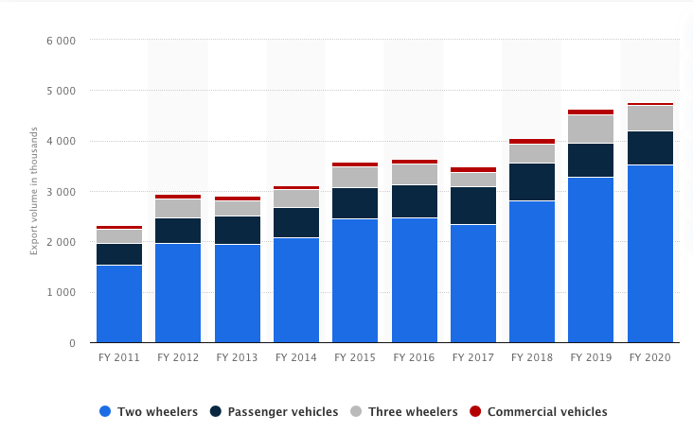
Graph 1. Export volume of automobiles from India from financial year 2011 to 2020 in thousand units

As seen in Graph 1, the value of car exports has increased from 2015 to 2020 with the exception of 2017 where there is a slight fall in exports. Other than this outlier, growth in terms of exports has risen from 3.5 million units in 2015 to around 4.7 million units in 2020. This growth can be attributed to MEIS. However, there could also have been other reasons behind this trend such as the Bonded Manufacturing scheme (which could account for 2019 and 2020 growth) and the previously growing trend in the industry from 2011 to 2015.

b. FAME
Through the FAME scheme, Make in India emphasises on increasing the sales of electric cars to reduce the emission of pollutants. Table 1 shows the funds allocated by the government to support the FAME scheme.

S. No. | Financial Year | Fund Allocated | Fund Utilization
1 | 2015-16 | Rs. 75 Crore | Rs. 75 Crore
2 | 2016-17 | Rs. 144 Crore | Rs. 144 Crore
3 | 2017-18 | Rs. 165 Crore | Rs. 165 Crore
4 | 2018-19 | Rs. 145 Crore | Rs.145 Crore
TOTAL |  | Rs. 529 Crore | Rs. 529 Crore
Table 1. investment in demand side incentives, charging infrastructure and R&D for EVs under the FAME scheme

Between 2015 and 2018, Rs. 529 crore was invested for increasing the sales of electric vehicles.
Graph 2 shows the sales of EVs in India over the years.

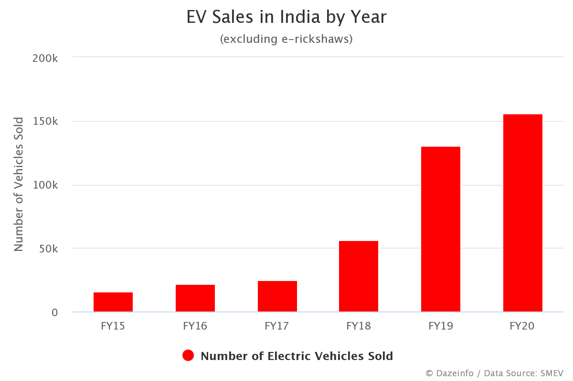
Graph 2. EV sales in India over the years

There has been a large increase in sales of cars from 2016 to 2020 (from 16,000 units to 156,000 units) as a result of the FAME scheme. This suggests that increasing demand side incentives and investing more in charging stations, etc. has been very successful.

Aside from ‘Make in India’ policies, there have also been other industrial policies used by the government to grow the automotive industry.

2. Impact of government policies on the automotive industry

Corporate tax cut (2019)
In 2019, to incentivize the producers in the auto industry, corporate tax was cut from 30% to 22%. In order to encourage foreign auto firms to start producing in India, their tax rate was even further lowered to 15% as long as they start before 31st March, 2023.
The total domestic sales of the two-wheelers increased by 16.88% to 20,53,814 units in October 2020 from 17,57,180 units in the same month last year. The total domestic sales of the passenger vehicles increased by 14.19% to 3,10,294 units in October 2020 from 2,71,737 units in October 2019.
Fig 5 shows the impact of corporate taxes on passenger vehicle sales .

Price of vehicles
Sales of vehicles
S1= S+30% tax
D
S2= S+22% tax
(Q1)271,737 (Q2)310,294
P1

P2

Fig 5. Impact of a corporate tax cut on price and quantity of passenger vehicles

After the tax cut, the supply curve shifted down from S1 (30% tax) to S2 (22% tax). Here we can see from the supply curves and their corresponding quantity and price that cutting taxes benefits auto producers by allowing them to sell a higher quantity at a lower price and consumers by letting them buy at a cheaper price. Comparing the sales before and after the tax cut suggests that some auto producers may have benefitted from the lowering of corporate taxes from 30% to 22% in 2019.

Bonded Manufacturing scheme on exports
The government scheme that lowers production costs is called the Bonded Manufacturing scheme.
This scheme was launched in October 2019. Under this scheme, producers can “import goods (both inputs and capital goods) under a customs duty deferment program. The duties are fully remitted if the processed goods are exported.” Its purpose is to encourage exports by lowering the costs of production when importing car parts. Since duties increase the total cost of production, firms will be encouraged to export so that they can avoid this unnecessary cost. This government scheme along with MEIS is what likely led to the increase in automobile exports from 2019 to 2020 as seen in Graph 1.

Tariffs on imported products
"To further incentivise the domestic value addition and Make in India in some such sectors, I propose to increase customs duty on certain items," the finance minister said.
In spite of the Bonded Manufacturing scheme (which neutralises tariffs if imported parts are used to export finished products), the government has imposed tariffs on certain cars and imported parts since 2015.
One reason for this is probably to lower the costs of buying locally produced cars for Indians by not encouraging producers to buy expensive parts from other countries but to source parts locally at a cheaper price. However, the main reason for the government to do this was to support Indian auto parts producers who might not have been able to compete with foreign parts producers prior to the imposition of the tariffs. The tariffs on foreign parts could have been imposed to restore the quantity of local parts bought from Q1 back to Q2.
Tariffs have also been imposed on imported commercial vehicles to encourage consumption of locally produced cars.

In 2015, the tariff rate for imported commercial vehicles was increased from 10% to 40%. The impact of the Indian government imposing the tariff on imported commercial vehicles can be seen on the production of local commercial vehicles.
Category | 2015-16 | 2016-17 | 2017-18 | 2018-19 | 2019-20
Commercial Vehicles | 786,692 | 810,253 | 895,448 | 1,112,405 | 752,022
Table 2. production of commercial vehicles in India

The production of commercial vehicles increased significantly in India ever since the tariff rates on imported commercial vehicles increased to 40% in 2015. Production of commercial vehicles grew significantly from 786,692 in 2015 to 1,112,405 in 2018. The reason for a fall in sales in financial year 2019-20 could have been covid-19, which adversely impacted demand and production of not just vehicles but most sectors. Based on the data available, the tariffs imposed on imported commercial vehicles were successful in boosting local production.

In 2017, a 15% tariff was introduced on radiators, wheels, exhaust pipes, steering wheels, silencers and several other parts.
In the 2018-19 Budget, the tariff rates on CBU (completely built unit) imports of motor vehicles were increased from 20% to 25%. The tariff rates on CKD (completely knocked down) imports of motor vehicles were increased from 10 percent to 15 percent. The rates for specified parts of motor vehicles was increased from 7.5% to 15%. Import rates on bus and truck tyres were increased from 10% to 15%. In 2019, the government lowered tariffs on components of electric vehicles from 15-30% to 10-15% to encourage domestic production of EVs using foreign parts.

Graph 2 shows the value of auto components imported into India from 2015 to 2019.
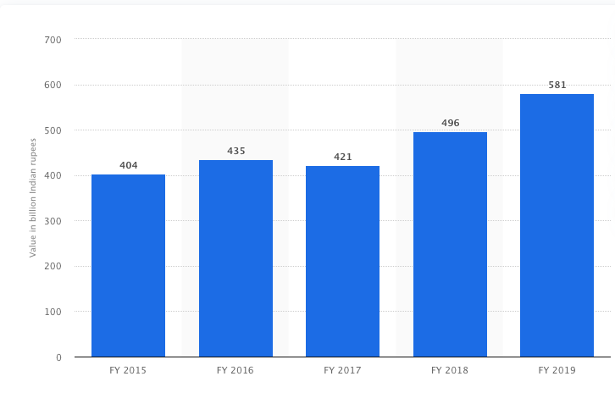
Graph 2. Value of auto component imports into India
The production of vehicles in India is shown in table 3.
Category | 2014-15 | 2015-16 | 2016-17 | 2017-18 | 2018-19 | 2019-20
Passenger Vehicles | 3,221,419 | 3,465,045 | 3,801,670 | 4,020,267 | 4,028,471 | 3,434,013
Commercial Vehicles | 698,298 | 786,692 | 810,253 | 895,448 | 1,112,405 | 752,022
Three Wheelers | 949,019 | 934,104 | 783,721 | 1022,181 | 1,268,833 | 1,133,858
Two Wheelers | 18,489,311 | 18,830,227 | 19,933,739 | 23,154,838 | 24,499,777 | 21,036,294
Quadricycle* |  | 531 | 1,584 | 1,713 | 5,388 | 6,095
Grand Total | 23,358,047 | 24,016,599 | 25,330,967 | 29,094,447 | 30,914,874 | 26,362,282

Table 3. production of vehicles in India over the years

Since the imposition of the 15% tariff on parts in 2017, the value of auto components grew from 421 to 496 (17.81%). This could have been because the quantity of imports did not change much, instead the additional tariff is what caused a majority of the increase in value of imports. A reason for the demand for imported parts being relatively unchanged after the tariff might be that the parts that were subject to duty were essentials which could not be substituted by locally produced parts due to quality, availability, etc. For this reason imposing a tariff on them may have been a bad move. The production of vehicles fell in 2019, but a major cause for that would have been the covid pandemic which made the auto industry sluggish. Because of this, data from 2019 is not being considered.

The total production increased from 29,094,447 to 30,914,847 units (6.26%) from 2017 to 2018. However, the rate of growth in production was higher from 2016 to 2017 before the tariffs were introduced. From 2016, the production of vehicles in India was 25,330,967, which grew to 29,094,447 in 2017. This growth of 14.86% was much more significant than the 6.26% growth in the next year, showing that the growth rate of vehicle production fell as a result of the tariffs on parts.

So, for these reasons, the tariffs on automotive components may have done more harm than good to the Indian automotive industry

Auto clusters
Automobile clusters are places where manufacturers in the automotive industry operate. There is a symbiotic relationship between manufacturers, part suppliers, related services and support industries which means that all producers in the area benefit from each other. All firms here have easy access to raw material, skilled labour and support infrastructure. Since all resources for production of automobiles are near factories, the cost of transporting these resources decreases, hence lowering the cost of production as well.
The new Automotive Mission Plan (AMP 2016-26) recognises the importance of automotive clusters since these emerging clusters will help contribute to achieving the targets set by it through increasing production, generating employment and facilitating exports. Indian auto clusters can be found in 7 cities – Ahmedabad, Bangalore, Chennai, Delhi NCR, Kolkata, Mumbai and Pune. These auto clusters will facilitate forward and backwards linkages which will help all producers in the automotive industry.

Policy recommendations
Since many companies rely on imported machinery from countries like Japan and Germany while setting up a plant overseas, high tariffs imposed by India discourages them to invest here.
One of my suggestions here is that the tariff on this CAPEX could be nil or nominal depending on a MOU (memorandum of understanding) between the government and the company basis a commitment to export a similar value of finished goods every year.
I have a similar suggestion where the company is reimbursed their additional costs on imported capital incurred through tariffs if they agree and are able to employ a certain number of people every year at an increasing rate.

These policies will complement the Bonded Manufacturing scheme as there will be new investors who can take advantage of it and increase exports while generating employment at the same time.

Limitations of the research
A major limitation in the research methodology used is that impacts of policies can on be measured on how they correlate with certain economic indicators. It can only be assumed that changes in economic indicators are caused due to the policy being analysed.

Conclusion
From the research undertaken, it can be concluded that the Make in India initiative has introduced policies to challenges faced by Indian producers in the automotive industry.
There have also been several government policies aimed at facilitating the growth of the Indian automotive industry apart from ‘Make in India’ although some policies such as the tariffs on imported parts did not yield ideal results.
The aim of the tariff on imports was to discourage producers from relying on other countries and making Indian auto companies more self-reliant and the Bonded Manufacturing scheme along with MEIS aims to increase automotive exports from India. This combined with the availability of Auto clusters provides auto manufacturers the opportunity to scale up production by increasing investment. This increase in investment will lead to formation of economies of scale that could not be attained without an increase in exports.
The FAME scheme aims to increase supply and demand for EVs, reducing negative externalities through pollution. Since the demand for EVs should increase in the future as countries try to increase their sustainability, producing them in India will lower our dependency on other countries for them.
So to answer my research question, Make in India policies and government policies for the automotive sector complement each other and aim to expand the Indian automotive industry and make it more self-reliant. Make in India policies have yielded good results in terms of improvements in Domestic production, domestic sales of vehicles and exports of the Indian automotive Industry.

Bibliography
- “Brand India.” IBEF, India Brand Equity Foundation, www.ibef.org/economy/make-in-india.
- “Make in India: The Vision, New Processes, Sectors, Infrastructure and Mindset - Make In India.” Make in India, www.makeinindia.com/article/-/v/make-in-india-reason-vision-for-the-initiative.

- Saurabh Parmar, et al. “Make in India : Objectives, Target, Funding, Stakeholders & Progress Card.” The Indian Wire, 25 Apr. 2020, www.theindianwire.com/politics/make-in-india-215144/.

- India, Make in. Automotive: Achievement Report - Make In India, Make in India, 2016, www.makeinindia.com/article/-/v/automotive-achievement-report.

- Miglani, Smita. “The Growth of the Indian Automobile Industry: Analysis of the Roles of Government Policy and Other Enabling Factors.” SpringerLink, Springer, Singapore, 1 Aug. 2018, link.springer.com/chapter/10.1007/978-981-13-8102-7_19.

- Bureau, PHD Research. “FDI Inflow in India Stands at 21 Billion Q1 2019-20.” Phdcci.in, 2019, www.phdcci.in/wp-content/uploads/2019/09/FDI-inflows-in-India-stands-at-USD-21-billion-during-Q1-2019-20.pdf.

- durongkaveroj, Wannaphong. “Hirschman's Linkages: Passé in the Age of Global Production Sharing?” Developing Economics, 24 June 2019, developingeconomics.org/2019/06/24/hirschmans-linkages-passe-in-the-age-of-global-production-sharing/.

- Heakal, Reem. “What Are Economies of Scale?” Investopedia, Investopedia, 16 Oct. 2020, www.investopedia.com/insights/what-are-economies-of-scale/.

- India, EEPC. “MEIS Scheme.” EEPC, 2016, www.eepcindia.org/MEIS/about-MEIS-scheme.aspx.

- ClearTax, ClearTax. “Merchandise Exports From India Scheme (MEIS).” Pinchy, ClearTax, 4 Jan. 2021, cleartax.in/s/merchandise-exports-india-scheme-meis.

- Keelery, Published by Sandhya, and Nov 24. “India: Export Trends in the Automobile Industry by Type 2020.” Statista, 24 Nov. 2020, www.statista.com/statistics/608494/export-trends-automobile-industry-india/.

- Delhi, PIB. “FAME India Scheme.” Press Information Bureau, 9 July 2019, pib.gov.in/PressReleasePage.aspx?PRID=1577880.

- Itu Rathore - October 3, Itu Rathore, et al. “Total EV Sales in India by Year: FY 2015 - 2020.” Dazeinfo, 28 May 2020, dazeinfo.com/2020/05/28/total-electric-vehicle-sales-in-india-by-year-graphfarm/.

- Ghosh, Malyaban. “Revival in Auto Sector May Be Round the Corner with the Corporate Tax Cuts.” Mint, 20 Sept. 2019, www.livemint.com/auto-news/revival-in-auto-sector-may-be-round-the-corner-with-the-corporate-tax-cuts-1568981234449.html.

- Singh, Varun. “Domestic Passenger Vehicle Sales Grow 14 per Cent, Two-Wheeler Sales Jump 17 per Cent in October 2020: SIAM.” India Today, 11 Nov. 2020, www.indiatoday.in/auto/latest-auto-news/story/domestic-passenger-vehicle-sales-grow-14-per-cent-two-wheeler-sales-jump-17-per-cent-in-october-2020-siam-1739991-2020-11-11.

- India, Invest. “Bonded Manufacturing & Warehousing Schemes: Invest India.” & Warehousing Schemes | Invest India, 2019, www.investindia.gov.in/bonded-manufacturing.

- India, SIAM. “Automobile Production Trends.” SIAM, SIAM, 2019, www.siam.in/statistics.aspx?mpgid=8&pgidtrail=13.
- gov, cbic. “CHAPTER 87.” Vehicles Other than Railway or Tramway Rolling-Stock, and Parts and Accessories Thereof, Cbic.gov.in, 2019, www.cbic.gov.in/resources//htdocs-cbec/customs/cst1718-010718/Chapter_87.pdf.

- Keelery, Published by Sandhya, and Oct 16. “India - Auto Components' Imports Value 2019.” Statista, 16 Oct. 2020, www.statista.com/statistics/918608/india-auto-components-imports-value/.

- India, SIAM. “Automobile Production Trends.” SIAM, SIAM India, 2019, www.siam.in/statistics.aspx?mpgid=8&pgidtrail=13.

- India, Make in. “India's Automobile Hubs.” India's Automobile Hubs - Make In India, 2017, www.makeinindia.com/article/-/v/india-s-automobile-hubs.

“Brand India.” IBEF, India Brand Equity Foundation, www.ibef.org/economy/make-in-india.
“Make in India: The Vision, New Processes, Sectors, Infrastructure and Mindset - Make In India.” Make in India, www.makeinindia.com/article/-/v/make-in-india-reason-vision-for-the-initiative.
Saurabh Parmar, et al. “Make in India : Objectives, Target, Funding, Stakeholders & Progress Card.” The Indian Wire, 25 Apr. 2020, www.theindianwire.com/politics/make-in-india-215144/.
India, Make in. Automotive: Achievement Report - Make In India, Make in India, 2016, www.makeinindia.com/article/-/v/automotive-achievement-report.
Miglani, Smita. “The Growth of the Indian Automobile Industry: Analysis of the Roles of Government Policy and Other Enabling Factors.” SpringerLink, Springer, Singapore, 1 Aug. 2018, link.springer.com/chapter/10.1007/978-981-13-8102-7_19.
Bureau, PHD Research. “FDI Inflow in India Stands at 21 Billion Q1 2019-20.” Phdcci.in, 2019, www.phdcci.in/wp-content/uploads/2019/09/FDI-inflows-in-India-stands-at-USD-21-billion-during-Q1-2019-20.pdf.
durongkaveroj, Wannaphong. “Hirschman's Linkages: Passé in the Age of Global Production Sharing?” Developing Economics, 24 June 2019, developingeconomics.org/2019/06/24/hirschmans-linkages-passe-in-the-age-of-global-production-sharing/.
Heakal, Reem. “What Are Economies of Scale?” Investopedia, Investopedia, 16 Oct. 2020, www.investopedia.com/insights/what-are-economies-of-scale/.
India, EEPC. “MEIS Scheme.” EEPC, 2016, www.eepcindia.org/MEIS/about-MEIS-scheme.aspx.
ClearTax, ClearTax. “Merchandise Exports From India Scheme (MEIS).” Pinchy, ClearTax, 4 Jan. 2021, cleartax.in/s/merchandise-exports-india-scheme-meis.
Keelery, Published by Sandhya, and Nov 24. “India: Export Trends in the Automobile Industry by Type 2020.” Statista, 24 Nov. 2020, www.statista.com/statistics/608494/export-trends-automobile-industry-india/.
Delhi, PIB. “FAME India Scheme.” Press Information Bureau, 9 July 2019, pib.gov.in/PressReleasePage.aspx?PRID=1577880.
Itu Rathore - October 3, Itu Rathore, et al. “Total EV Sales in India by Year: FY 2015 - 2020.” Dazeinfo, 28 May 2020, dazeinfo.com/2020/05/28/total-electric-vehicle-sales-in-india-by-year-graphfarm/.
Ghosh, Malyaban. “Revival in Auto Sector May Be Round the Corner with the Corporate Tax Cuts.” Mint, 20 Sept. 2019, www.livemint.com/auto-news/revival-in-auto-sector-may-be-round-the-corner-with-the-corporate-tax-cuts-1568981234449.html.
Singh, Varun. “Domestic Passenger Vehicle Sales Grow 14 per Cent, Two-Wheeler Sales Jump 17 per Cent in October 2020: SIAM.” India Today, 11 Nov. 2020, www.indiatoday.in/auto/latest-auto-news/story/domestic-passenger-vehicle-sales-grow-14-per-cent-two-wheeler-sales-jump-17-per-cent-in-october-2020-siam-1739991-2020-11-11.
India, Invest. “Bonded Manufacturing & Warehousing Schemes: Invest India.” & Warehousing Schemes | Invest India, 2019, www.investindia.gov.in/bonded-manufacturing.
India, SIAM. “Automobile Production Trends.” SIAM, SIAM, 2019, www.siam.in/statistics.aspx?mpgid=8&pgidtrail=13.
gov, cbic. “CHAPTER 87.” Vehicles Other than Railway or Tramway Rolling-Stock, and Parts and Accessories Thereof, Cbic.gov.in, 2019, www.cbic.gov.in/resources//htdocs-cbec/customs/cst1718-010718/Chapter_87.pdf.
Keelery, Published by Sandhya, and Oct 16. “India - Auto Components' Imports Value 2019.” Statista, 16 Oct. 2020, www.statista.com/statistics/918608/india-auto-components-imports-value/.
India, SIAM. “Automobile Production Trends.” SIAM, SIAM India, 2019, www.siam.in/statistics.aspx?mpgid=8&pgidtrail=13.
India, Make in. “India's Automobile Hubs.” India's Automobile Hubs - Make In India, 2017, www.makeinindia.com/article/-/v/india-s-automobile-hubs.

